**FINAL PROJECT REPORT**



**FOOD WASTE IN DINING SERVICES**

**ADTA 5240- Harvesting, Storing, and Retrieving Data**

**Dr. Schenita Floyd**

**December 6, 2023**

**Group- 15**

Sharath Chandra Reddy Yedavalli

Sushanth Reddy Marreddy

Prem Chand Kothapalli

Meghana Desetty

Hemavalli Gollapudi

Prakash Chiluvuru

# Executive Summary

# Introduction:

# Food waste is a global issue where dining services like university dining halls, hospitals, markets, and restaurants are significant contributors and have a huge amount of food waste generated. This uneaten food generation has not only an impact on the environment but also has financial loss with huge amounts of investments in it (Leal Filho et al., 2023). However, this project aims to study the issue and implement necessary steps to prevent food wastage further in the dining services revolves around handling the eight stages of the data life cycle: Generation, Collection, Processing, Storage, Management, Analysis, Visualization, and Interpretation (HBS Online, 2021). Each stage plays a crucial role in extracting meaningful insights from the raw data collected from the publicly available sites and contributing to informed decision-making processes.

**Body (Structure):**

# Static and Streaming datasets are generated from various sources in the U.S., and they are readily available through websites or links such as data.gov and insights engine ReFED, ensuring the authenticity and reliability of the information. These datasets are collected from the website as a csv file and used for further analysis of food wastage.

# The data collected is processed using the Open Refine tool, which offers a versatile set of tools where the data can be cleaned for null values, data inconsistency, changing formats, remove unwanted columns etc. (Ramírez-Gallego et al., 2017). This phase ensures that the data is in structured and usable format. This processed and cleaned data can be used further by the next phases of data lifecycle.

# In the storage phase, a project is created by the name “ADTA5240F23G15”. After the creation of the project, the bucket is created along with the clusters and the dataset files are stored in the bucket. The clusters can be managed with the help of manager and worker nodes. The manager node can be used to run the Hadoop system for Hive and Spark analysis for the dataset files stored in the bucket. BigQuery can also be used to manage and analyze the data with its inbuilt capabilities such as ML, and business intelligence (Google Cloud, n.d.). The management stage also involves version control, ensuring governance, orchestrating the data flow and seamless accessibility for downstream process.

# With the help of Hadoop commands, Hive and Spark tools enable the execution of the complex queries, with a focus on runtime efficiency. By creating tables in Hive and Spark This helps to extract appropriate results by running SQL queries easily and faster with it on both platforms, required data can be taken using SQL queries.

**Conclusion:**

Based on the above generated results from Hive and Spark analysis, it can be known that Hive took more time than Spark. However, Hive can be used for performing data analytics on large sets of data, whereas Spark can be used for running big data analytics with a faster approach and time (Berman, n.d.). Furthermore, this analysis can be used by data scientists and data analytics for visualization and interpreting results. Based on these, data scientists and analysts can enhance the future impact on food waste and analyze more efficient solutions to it.

# Data Generation and Collection:

**Static Dataset Reference and link:** Vermont Center for Geographic Information. (2023, September 15). Food Scrap Generators. *DEC, Waste Management and Prevention Division*. <https://catalog.data.gov/dataset/food-scrap-generators-caa50>

*Website link:*Data.gov - <https://data.gov/>

This dataset is collected from data.gov. This dataset has food waste data collected from various sources such as hospitals, restaurants, schools, colleges, etc. in the state of Vermont.

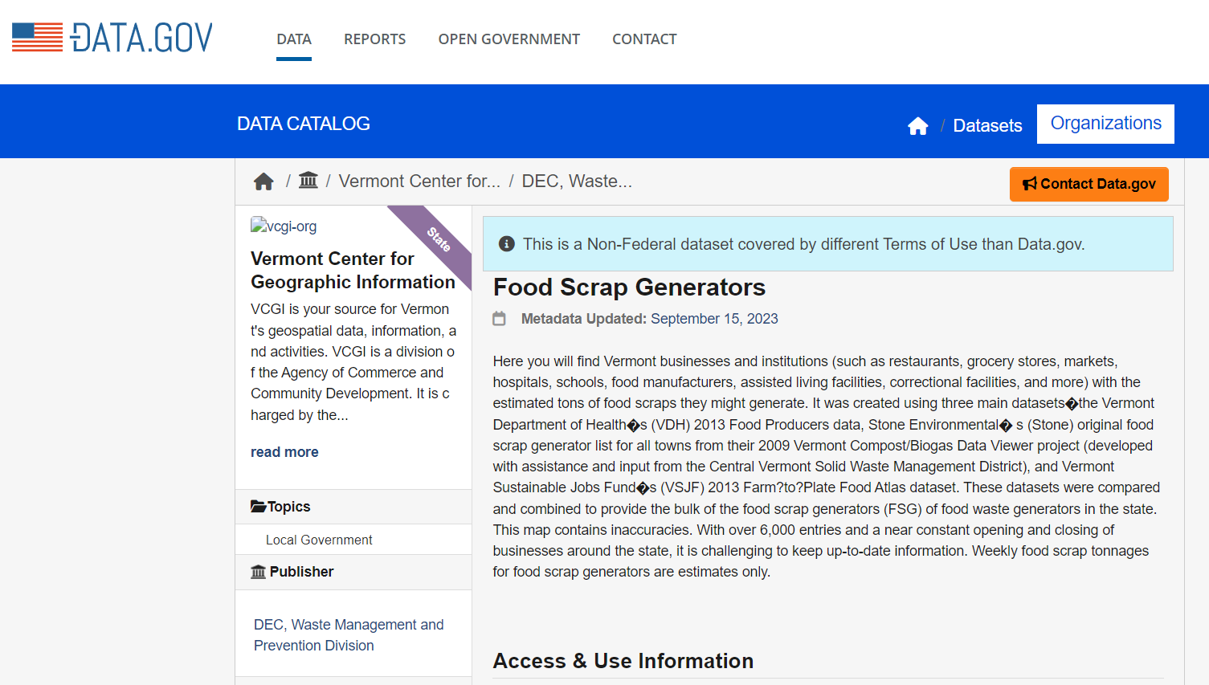

**Streaming Dataset 1 Reference and link:** ReFED Insights Engine. (n.d.). *Food waste monitor*. <https://insights-engine.refed.org/food-waste-monitor?view=overview&year=2021>

*Website link:*insights-engine.refed.org - <https://insights.refed.org/?_ga=2.91862170.1051283044.1701466352-538034373.1701466352>

This dataset is taken from the ReFED insights engine which monitors the food waste generated and the cause of wastage in the U.S.

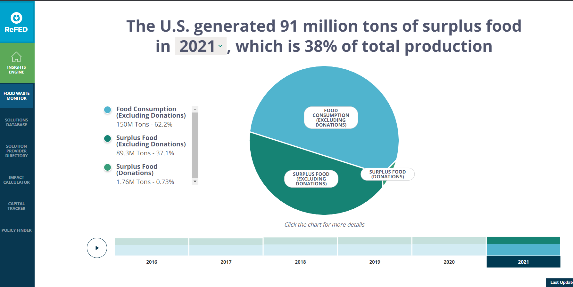

**Streaming Dataset 2 Reference and link:** Town of Cary, North Carolina. (2023, November 24). Food Waste Recycling Impact. *Cary*. <https://catalog.data.gov/dataset/food-waste-recycling-impact>

*Website link:*Data.gov - <https://data.gov/>

This dataset is extracted from the data.gov website where it collects real-time data of food waste from all the sources in the Town of Cary, North Carolina state. This dataset is updated every month for food wastage collection.

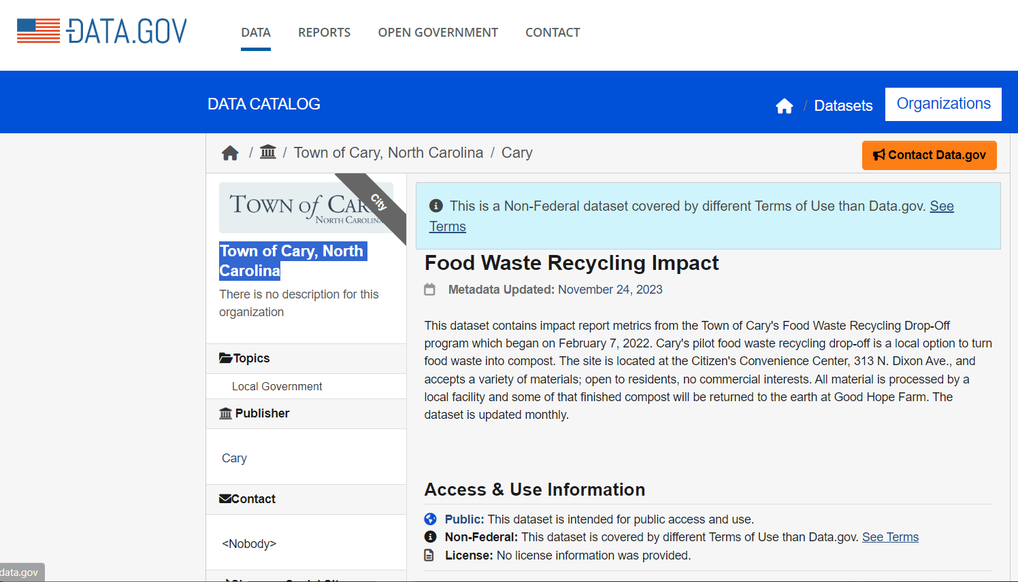

**Data Processing:**

Performed data processing like cleaning the dataset and removing unwanted rows and columns using OpenRefine for both static and streaming datasets.

***Static Dataset:*** Arranging all the columns with ‘ID’ as the starting column. Changing the ‘ID, Zip, TonsPerWeek, X, Y, Active’ columns are transformed from text to number.

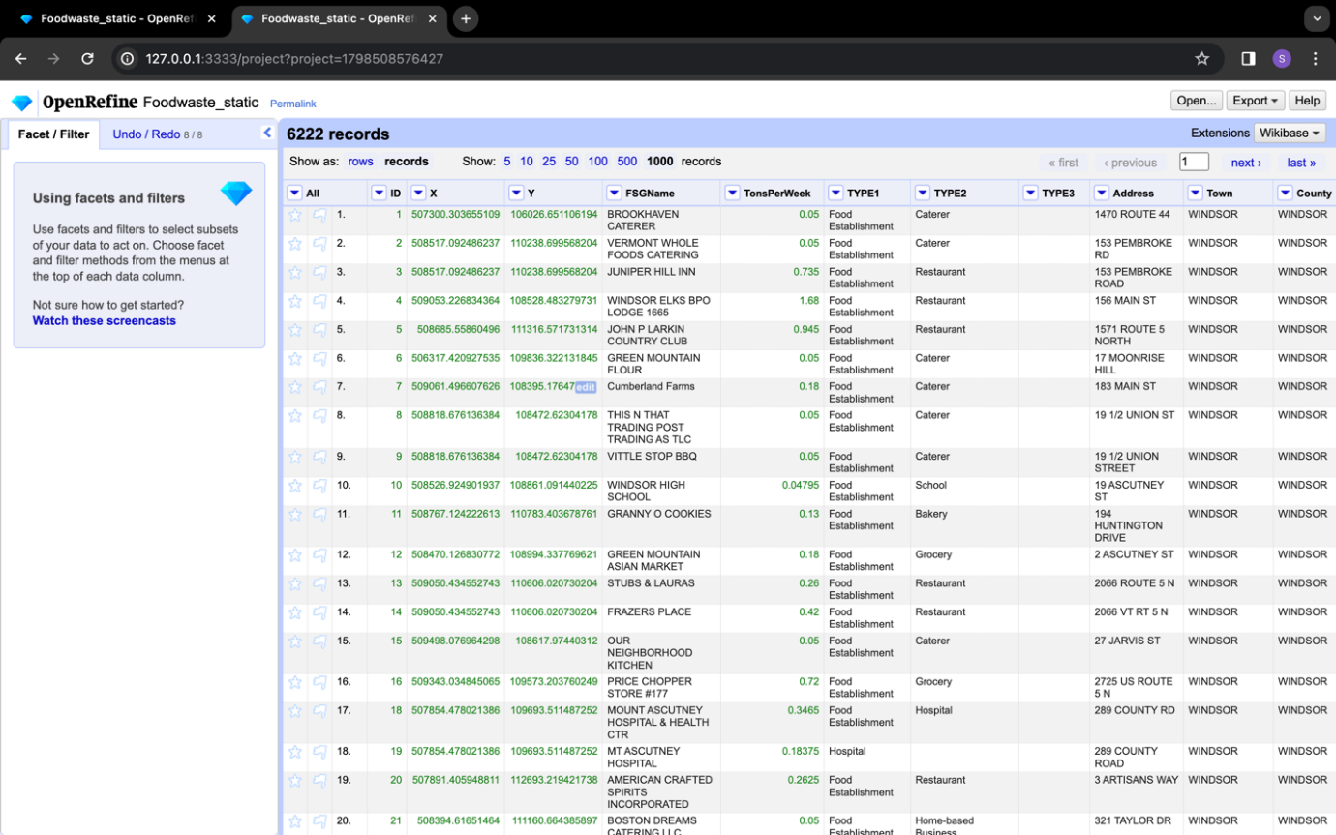

Creating clusters for the columns ‘FSGName’ and ‘County’, and all clusters with similar names are transformed into one and filling down the values to store in blank cells.

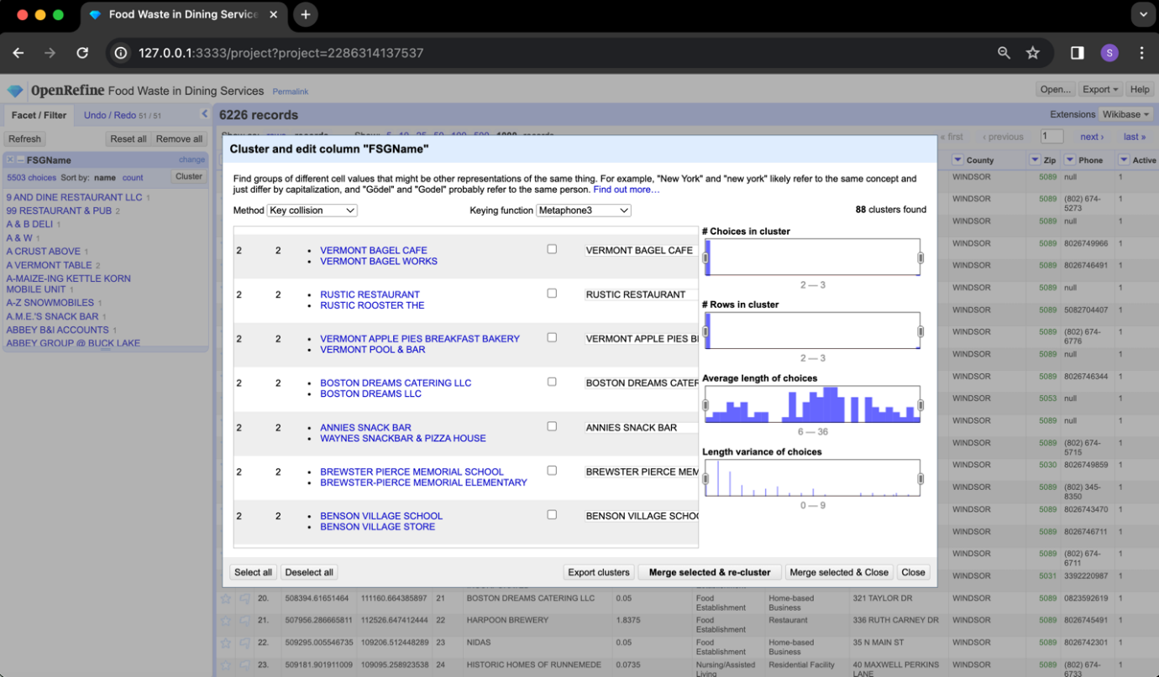

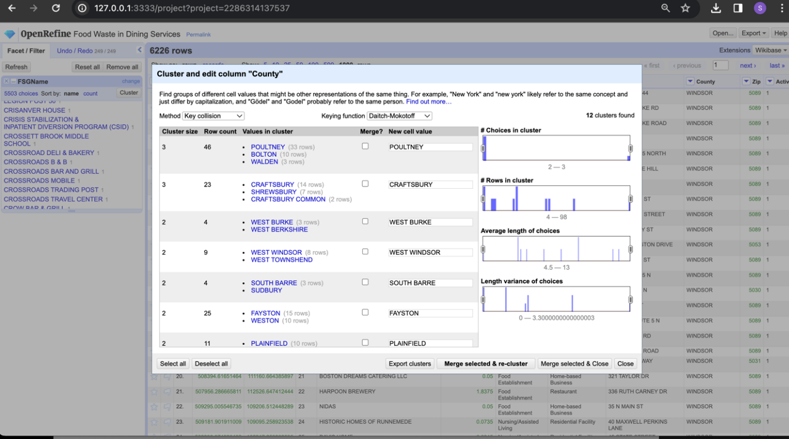

Removed unwanted columns like Type3, Phone, Website, and Facebook from the dataset.

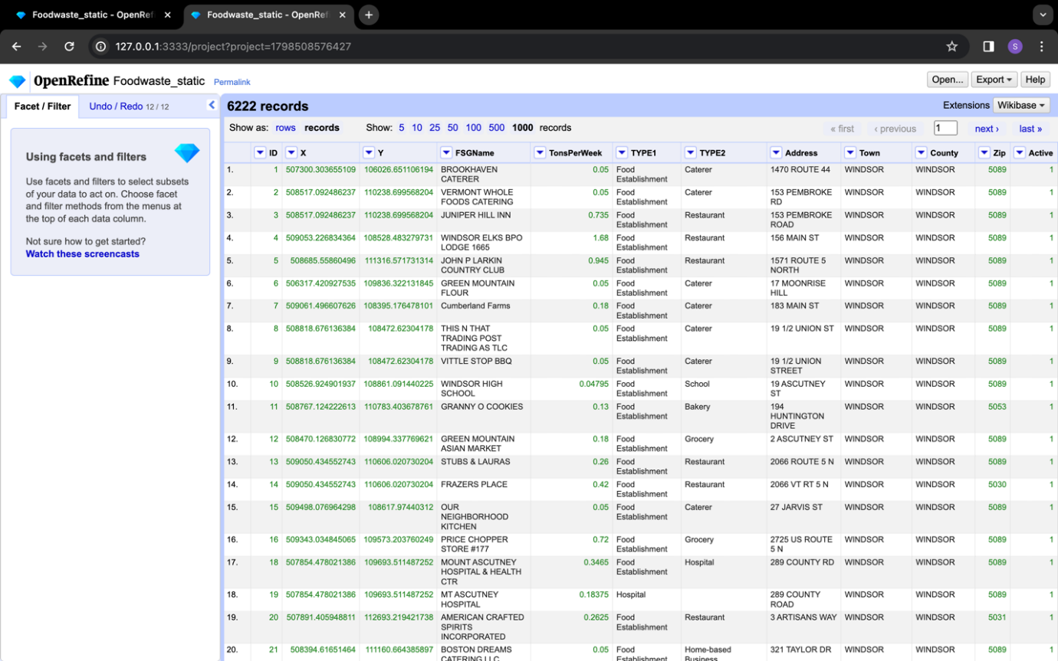

Changed all the null zip codes to specific value based on their county.

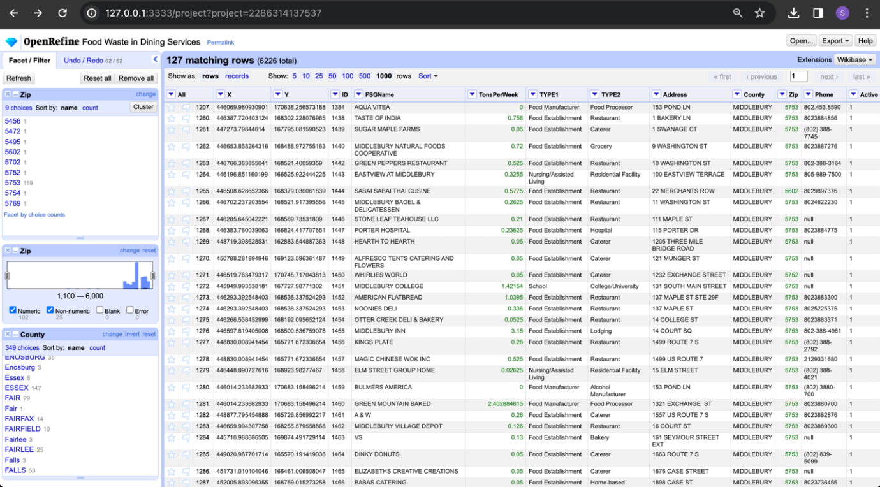

Renamed the column names for easy identification.

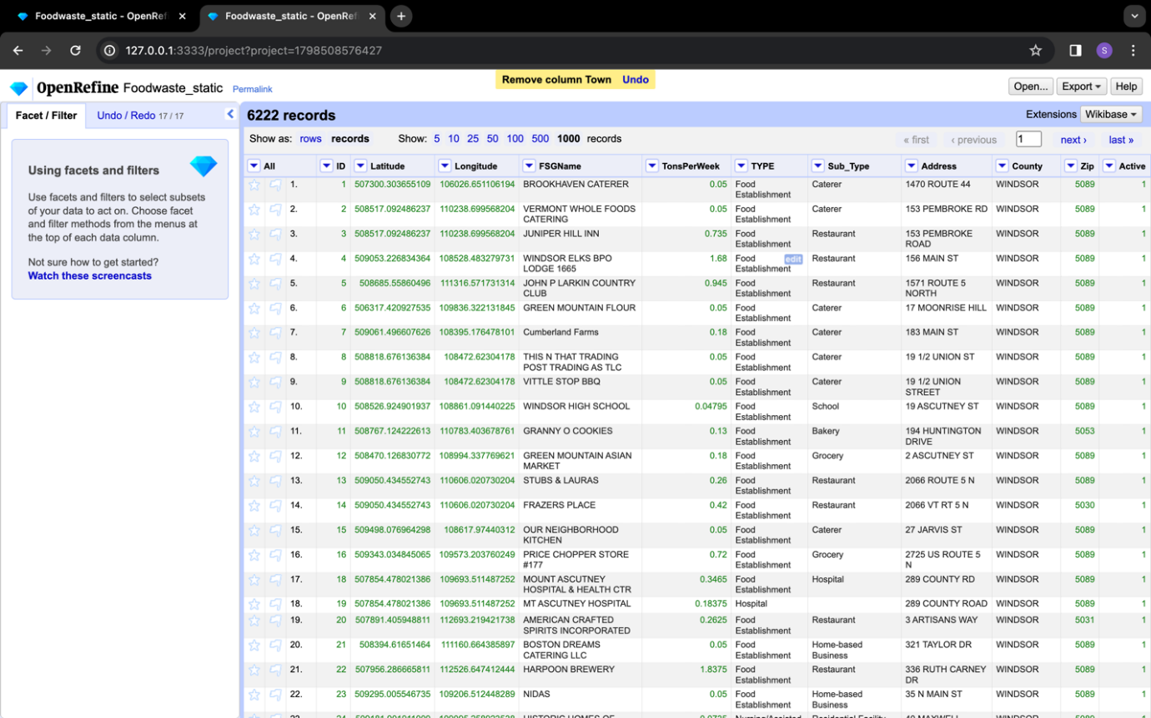

***Streaming Dataset 1:*** Created a project as shown in the below image.

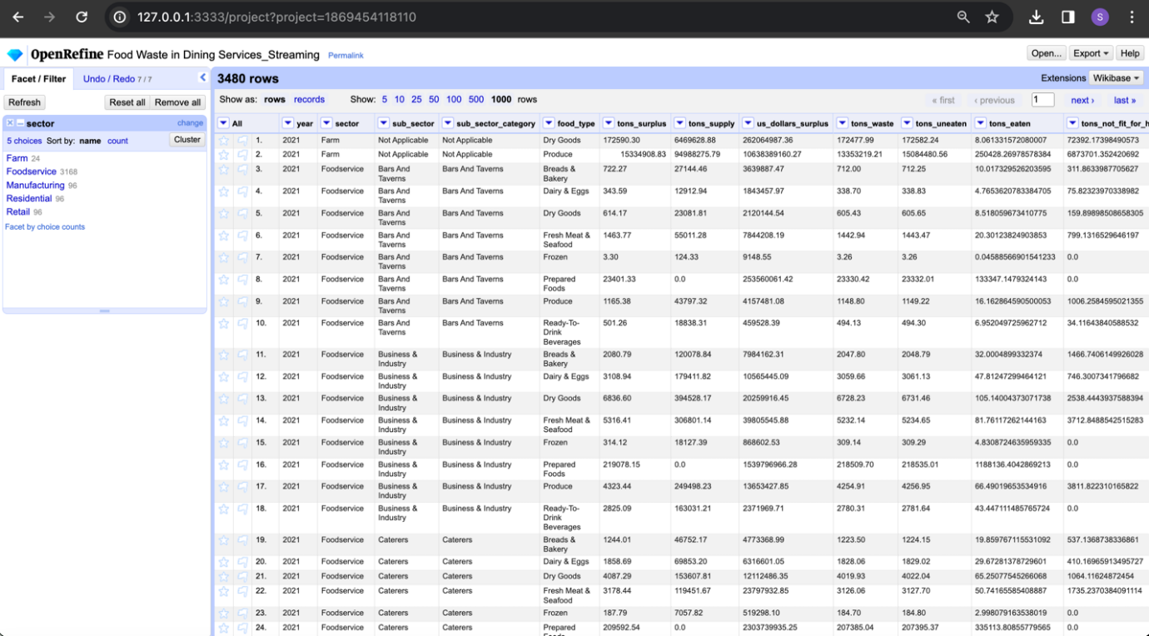

Transforming the column data to store up to 3 digits after decimal in all the required columns.

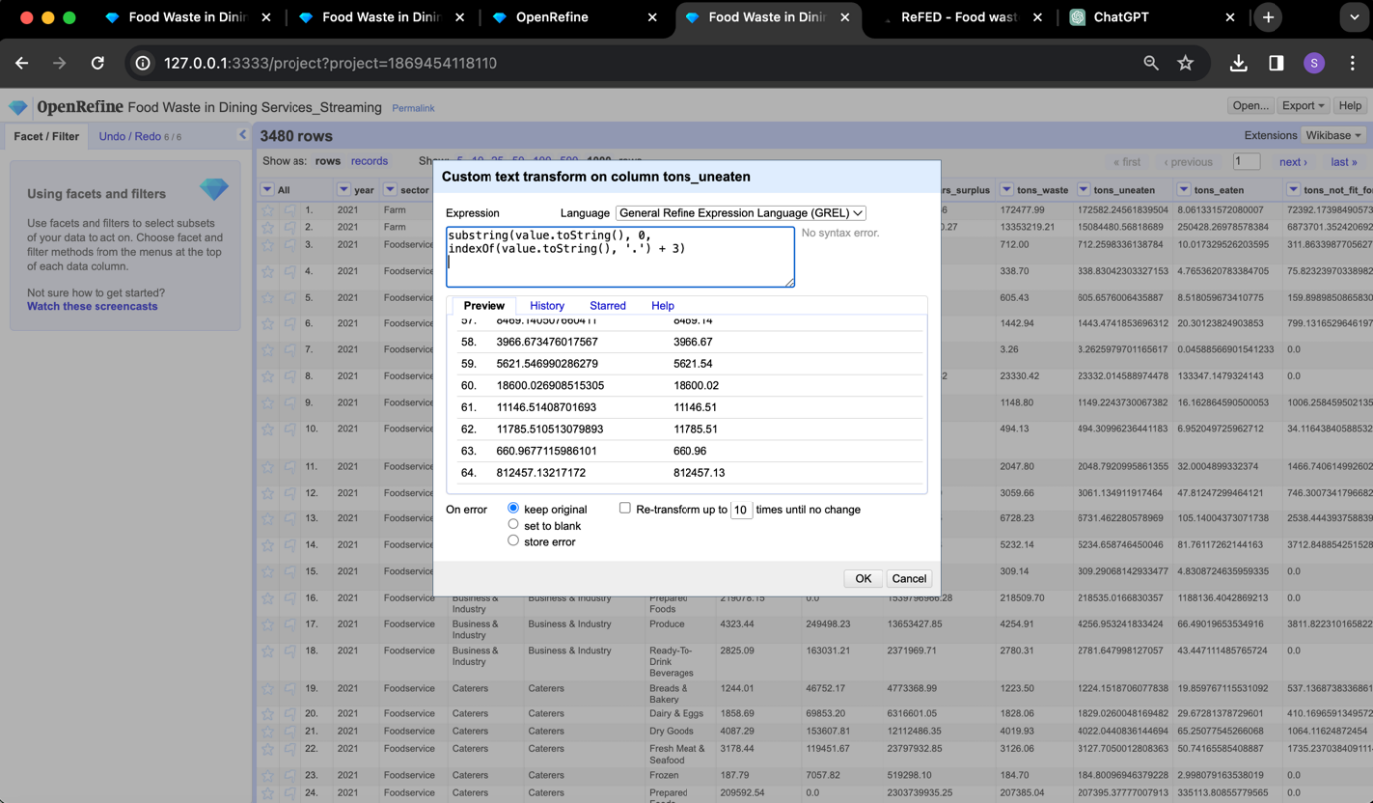

Transforming columns from text to number format and creating a cluster for Food_type, sector, sub_sector, cause_group and cause_name and combining all the similar names into one.

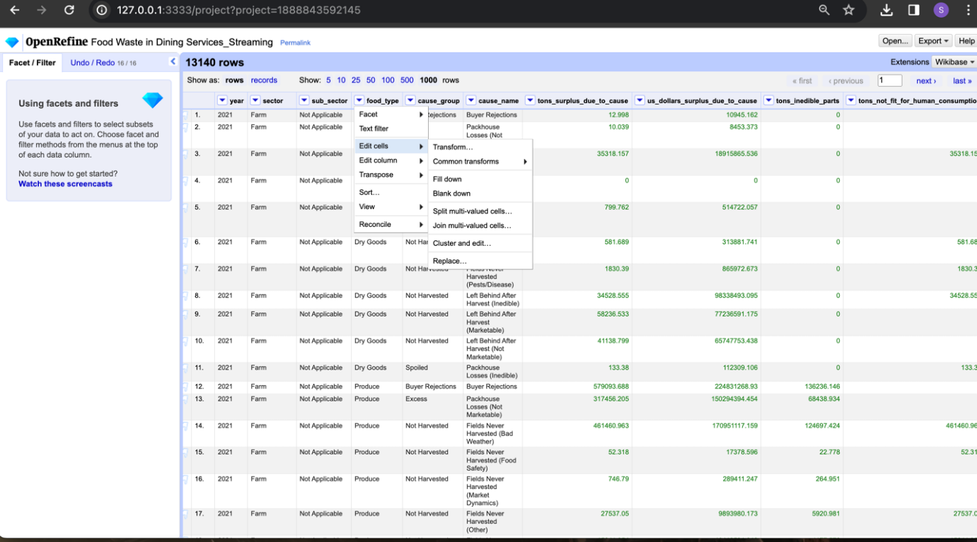

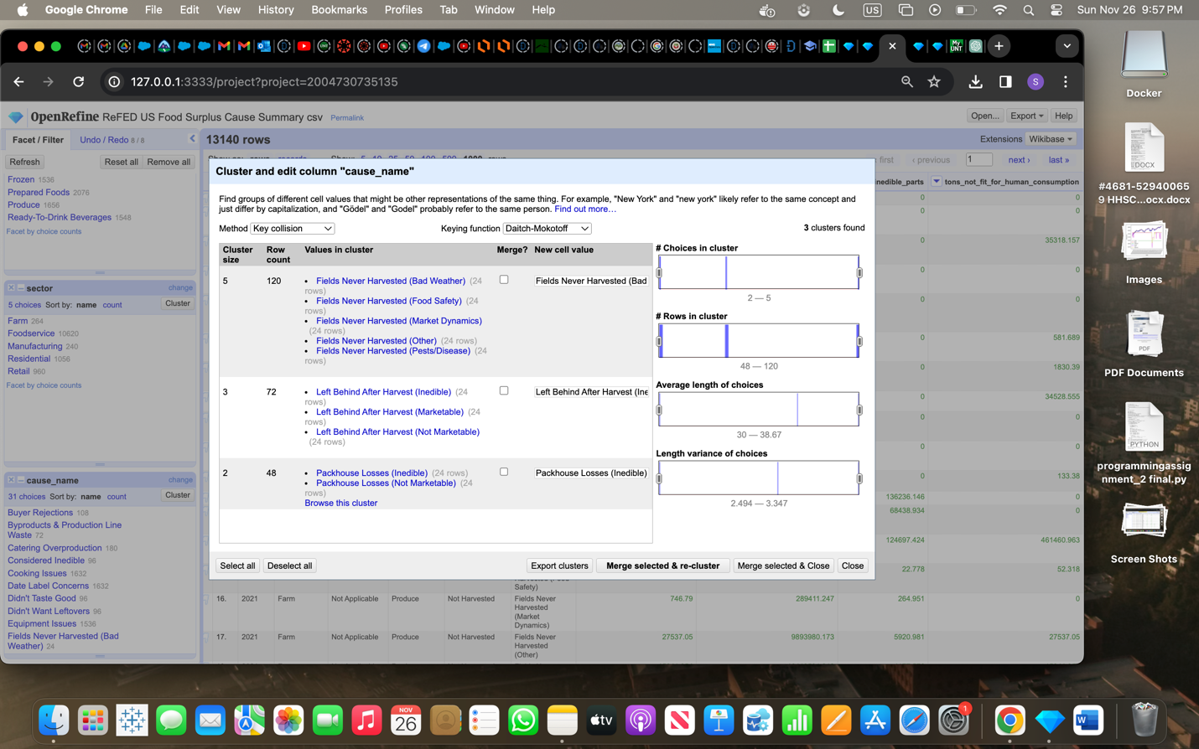

***Streaming Dataset 2:*** Created a project as shown in the below image.

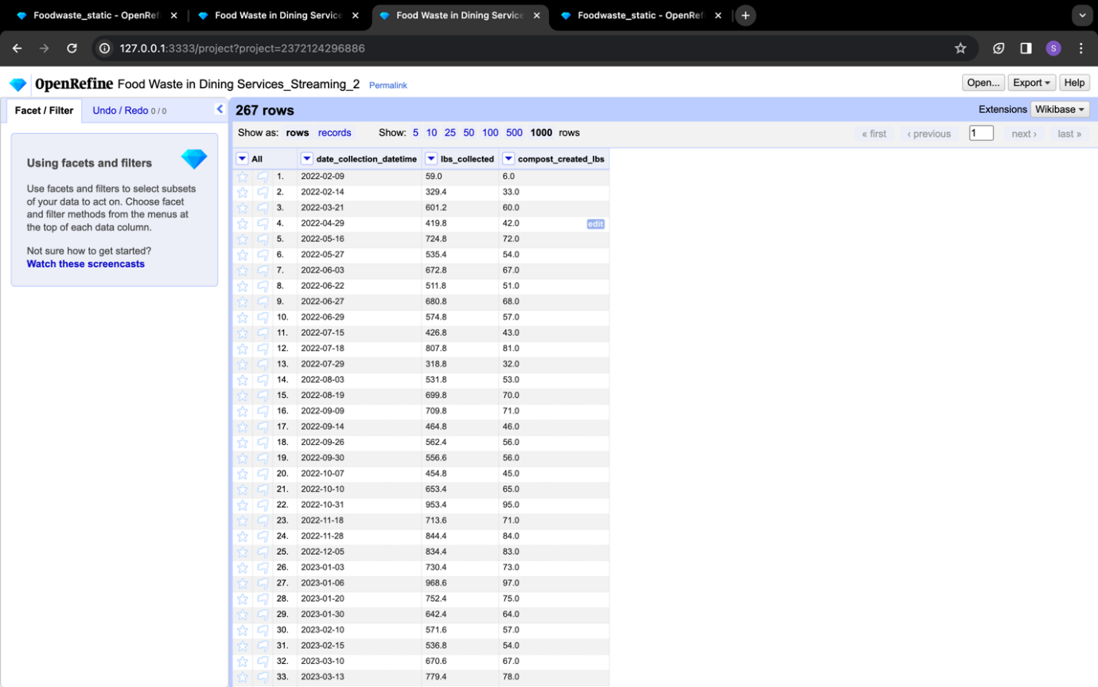

Changed the column to date format.

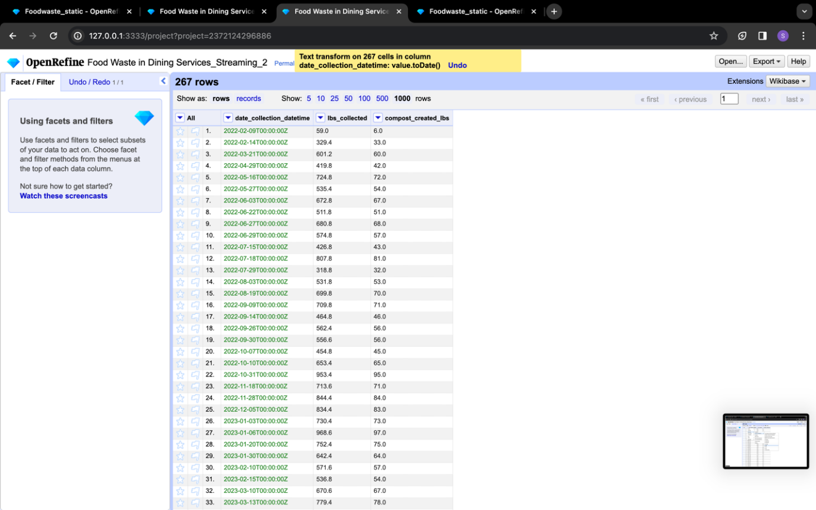

Changing the format of columns from text to numeric format and verified for null values in the dataset.

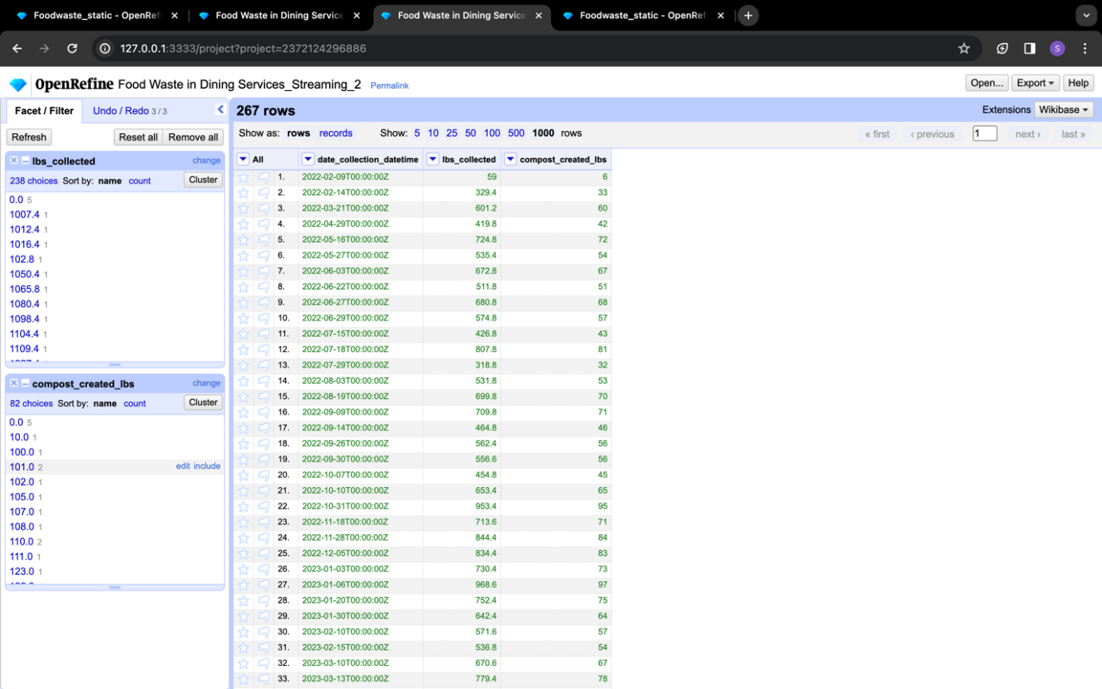

**Data Storage and Management:**

Created a project named “ADTA5240F23G15” in GCP.

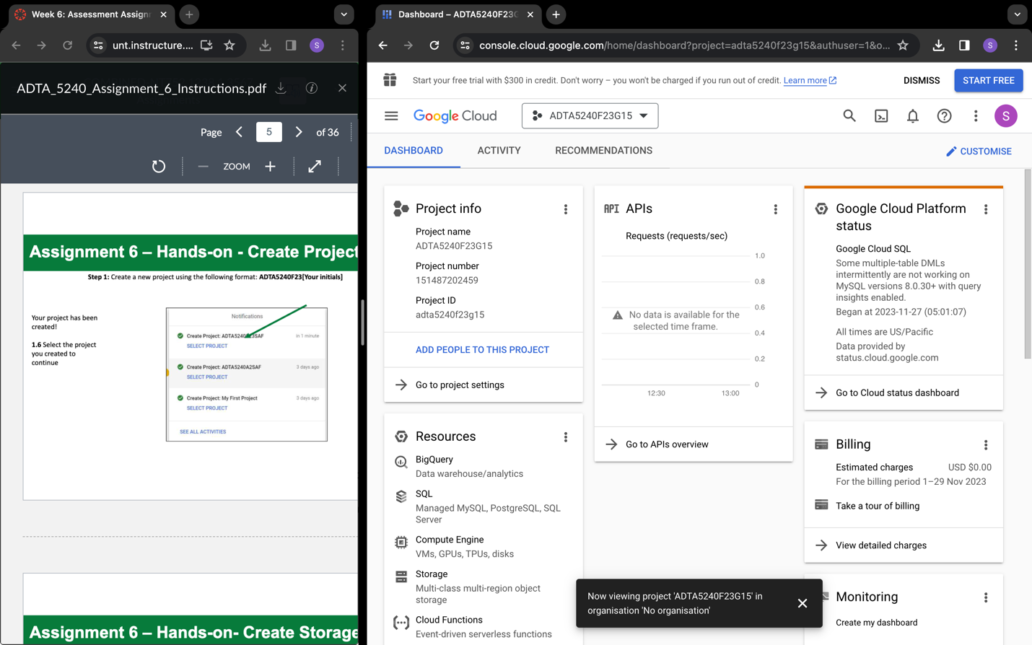

Created a storage bucket and stored files in it.

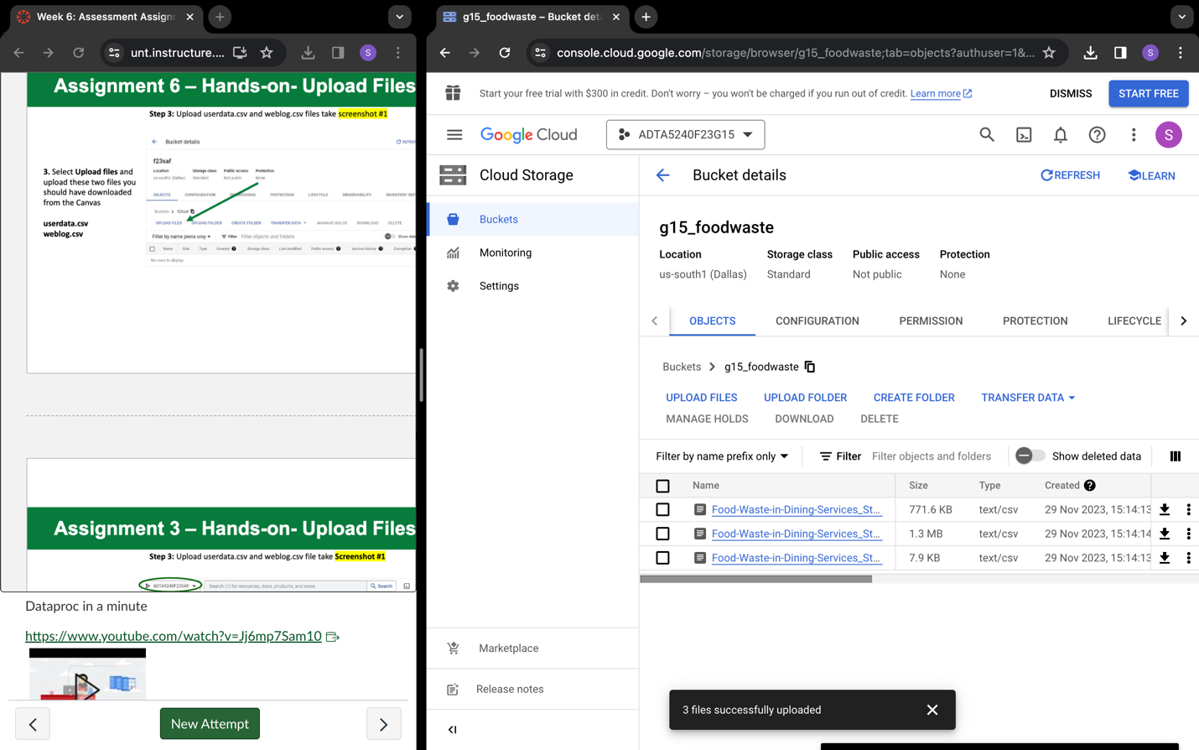

Created cluster along with manager and worker nodes.

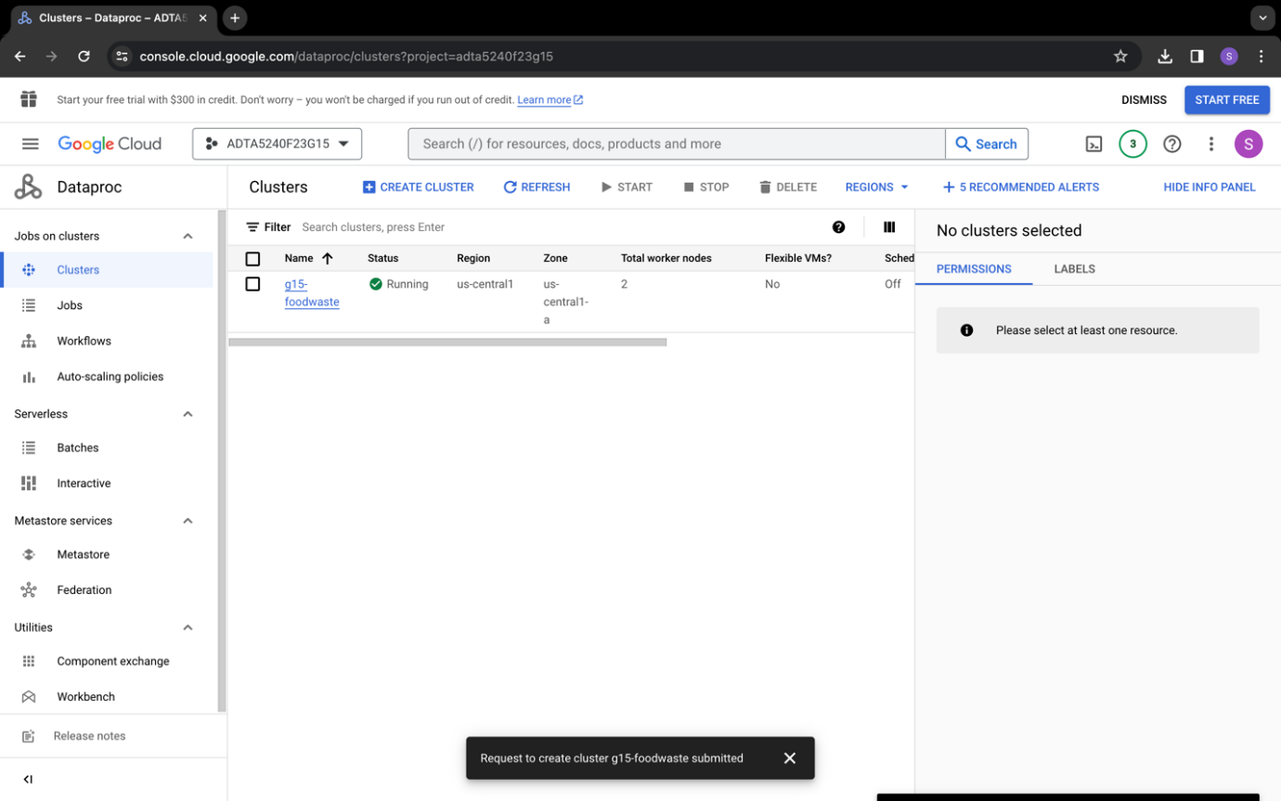

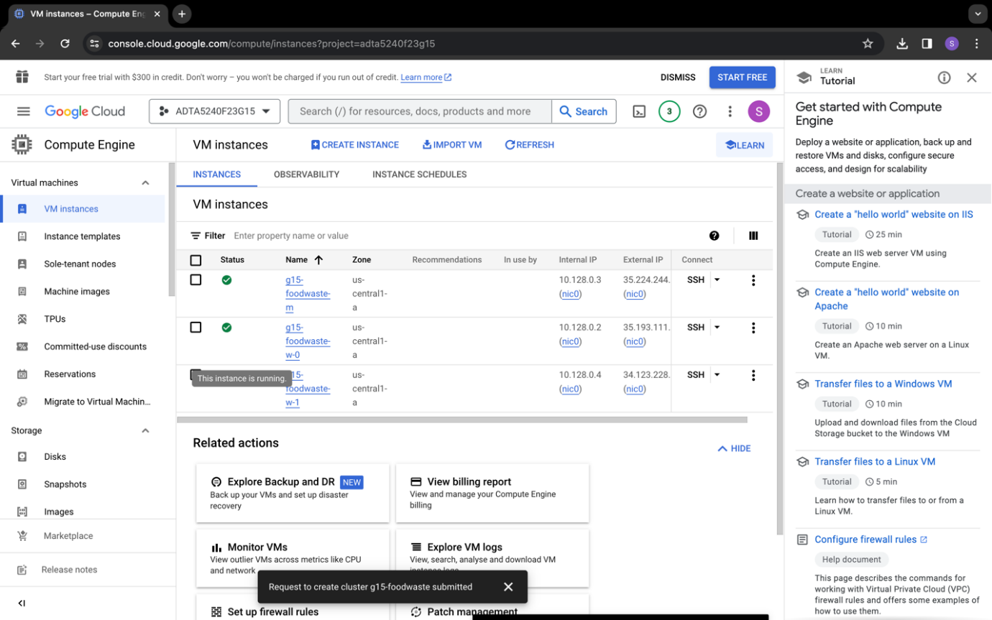

**BigQuery:** Enabling BigQuery API and executed queries for data verification for both static and streaming datasets. (Few screenshots attached here)

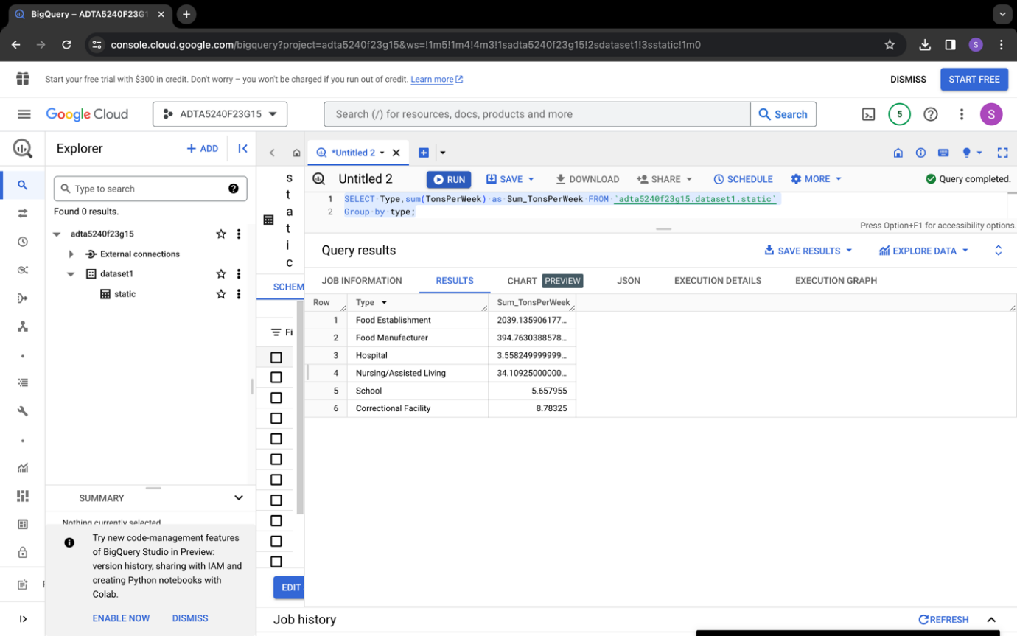

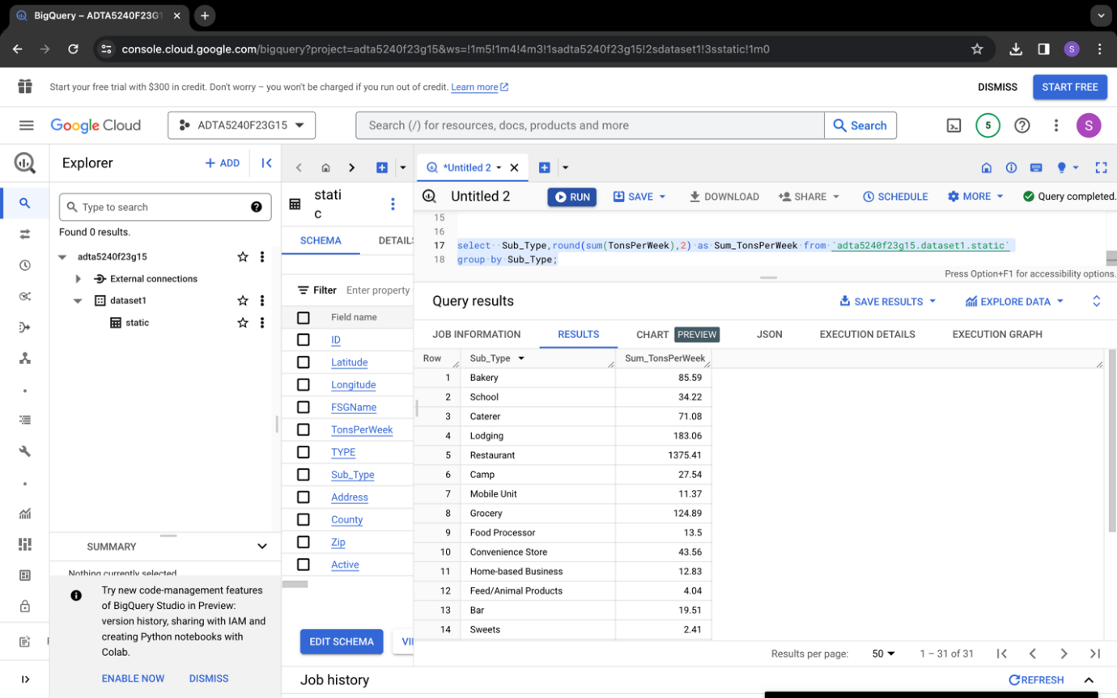

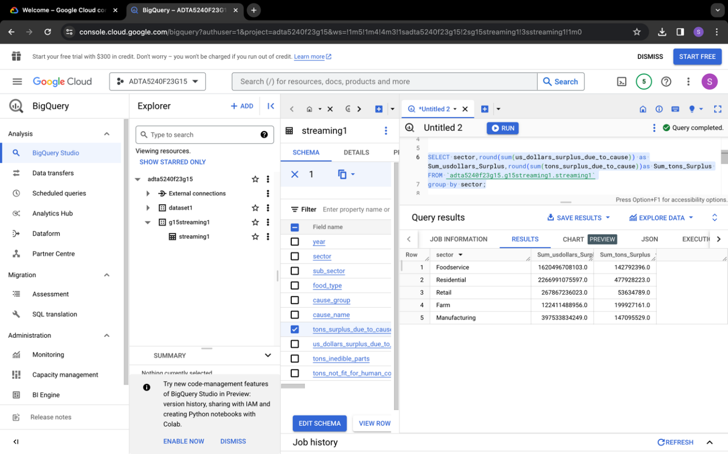

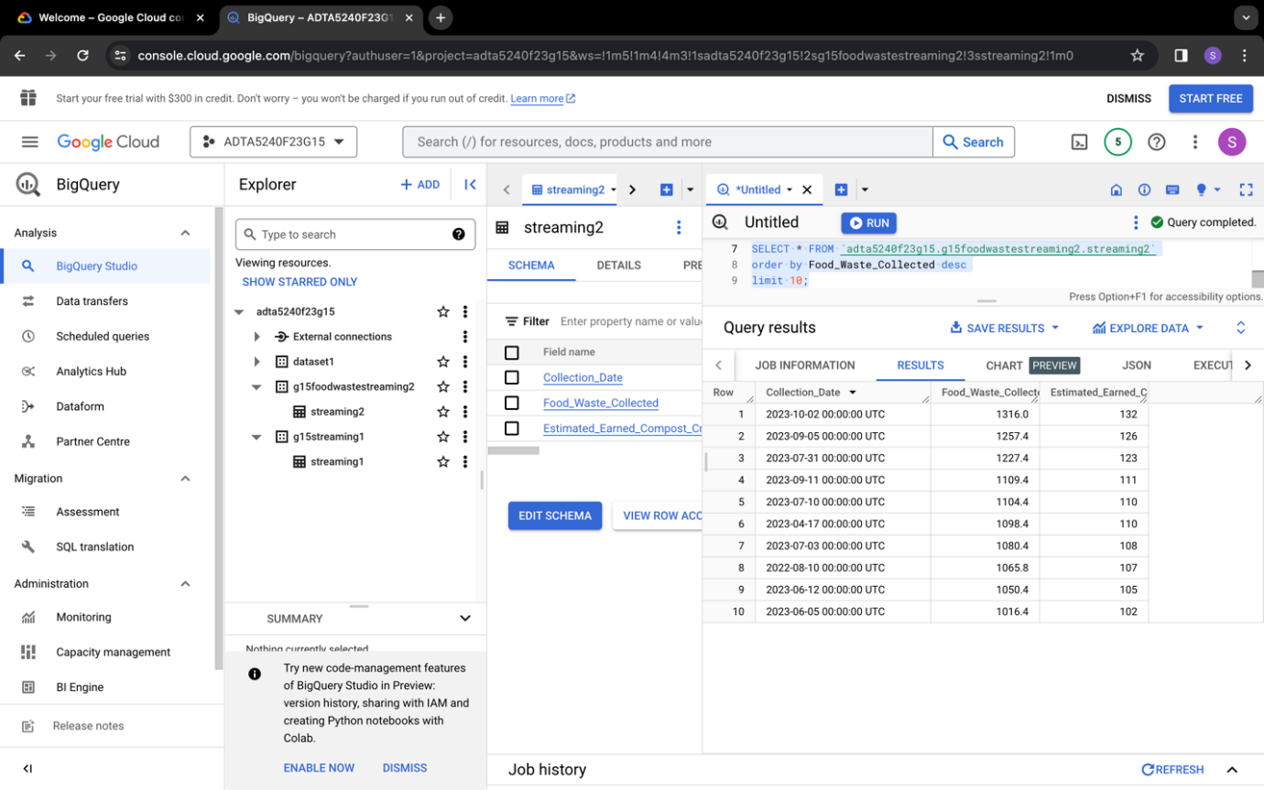

Further monitored the results of the cluster and monitored various parameters from it.

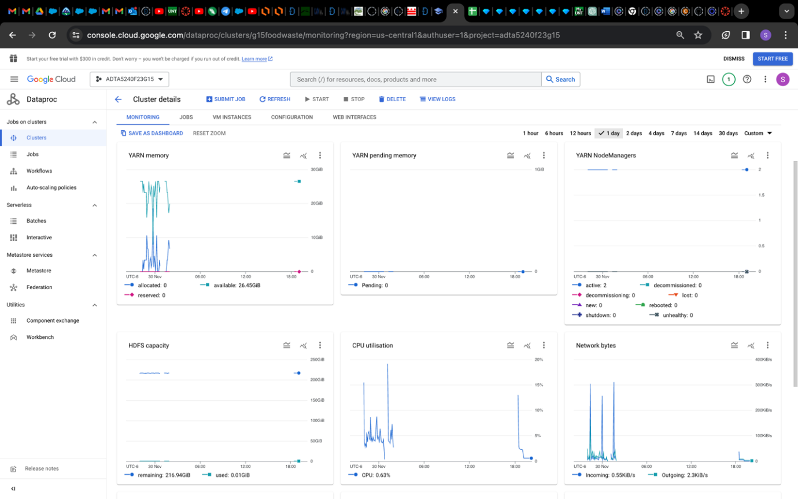

**Data Analysis:**

This is performed using Hive and Spark SQL executing various queries for both static and streaming datasets. For this created a project directory and copied dataset files to the directory using Hadoop Linux commands.

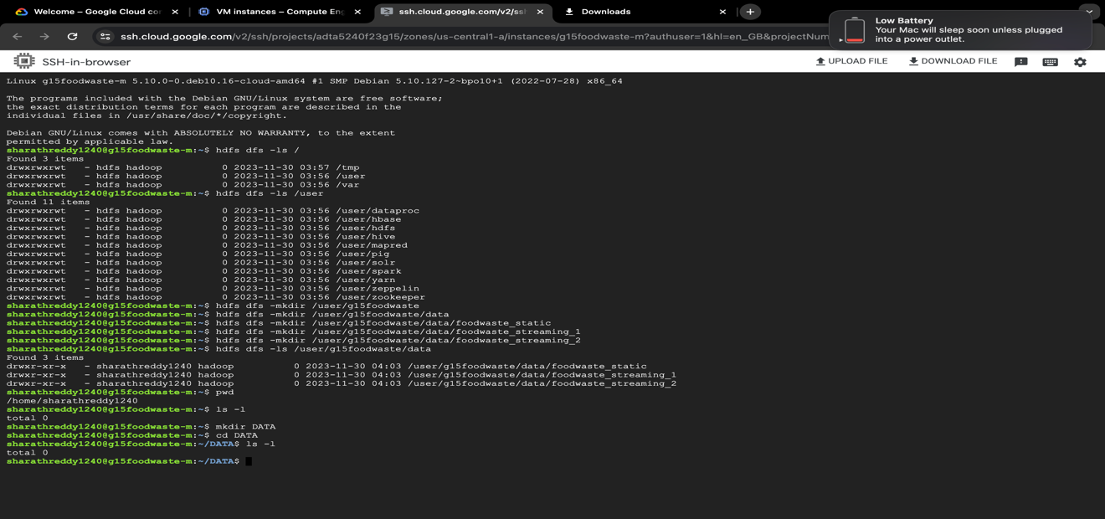

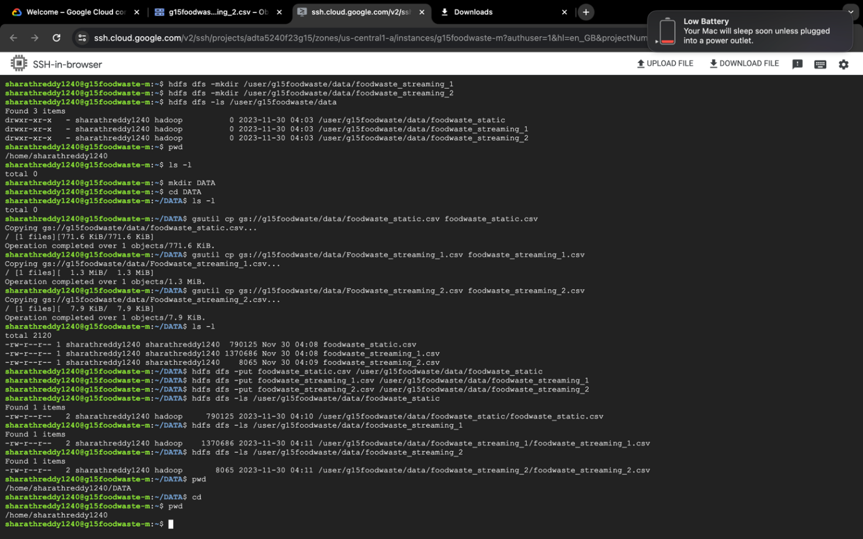

**Hive:**

*Static Dataset:*

Now, connecting to the **hive** and creating tables for the dataset to generate results for some queries.

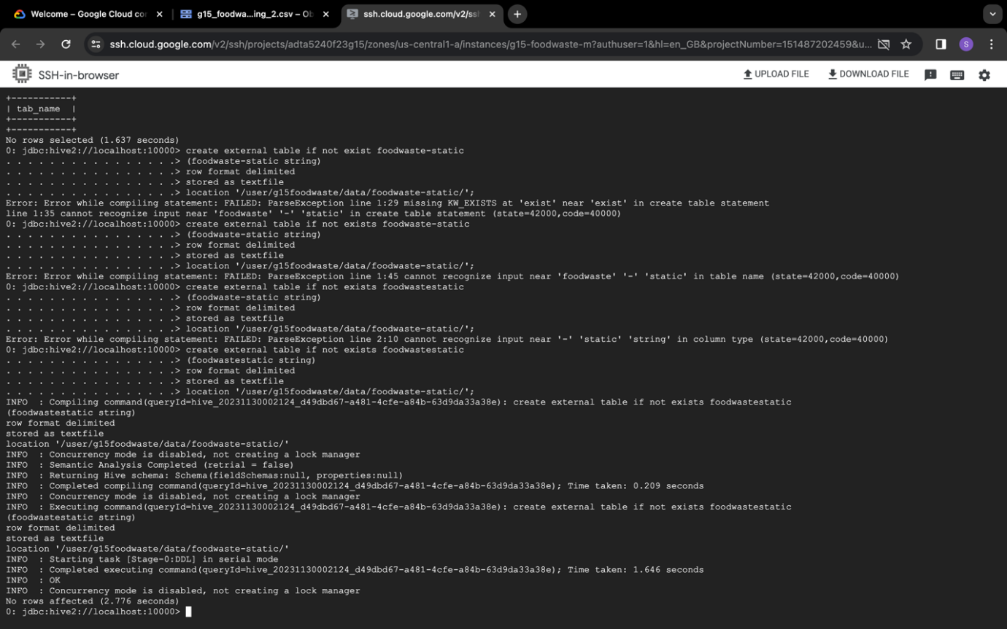

Query1: SELECT TYPE, round(sum(TonsPerWeek),2) as Sum_TonsPerWeek, County FROM foodwastestatic_1

Group by TYPE, County

Order by County;.

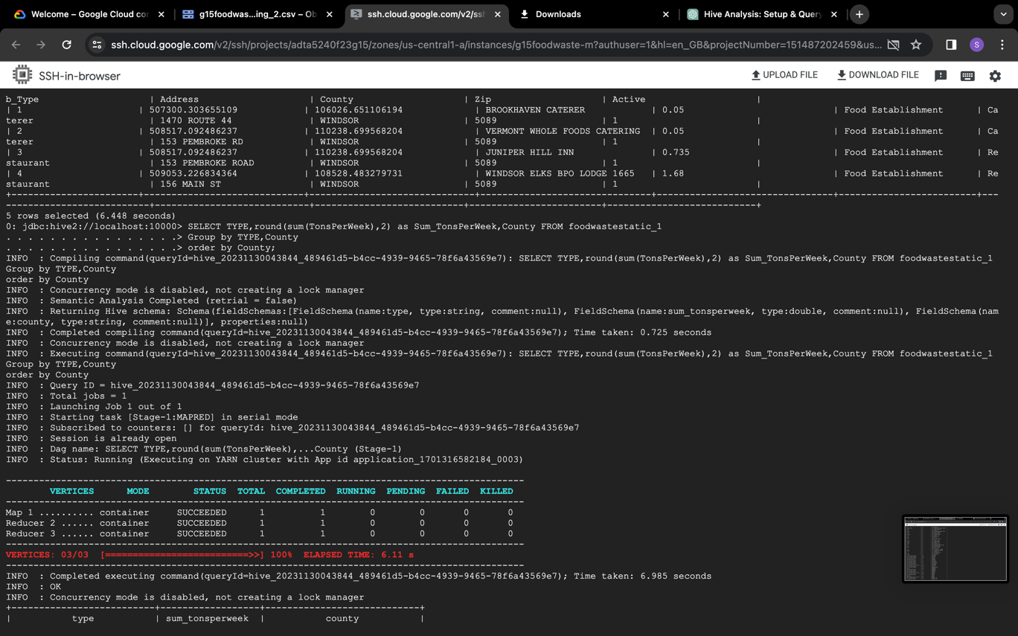

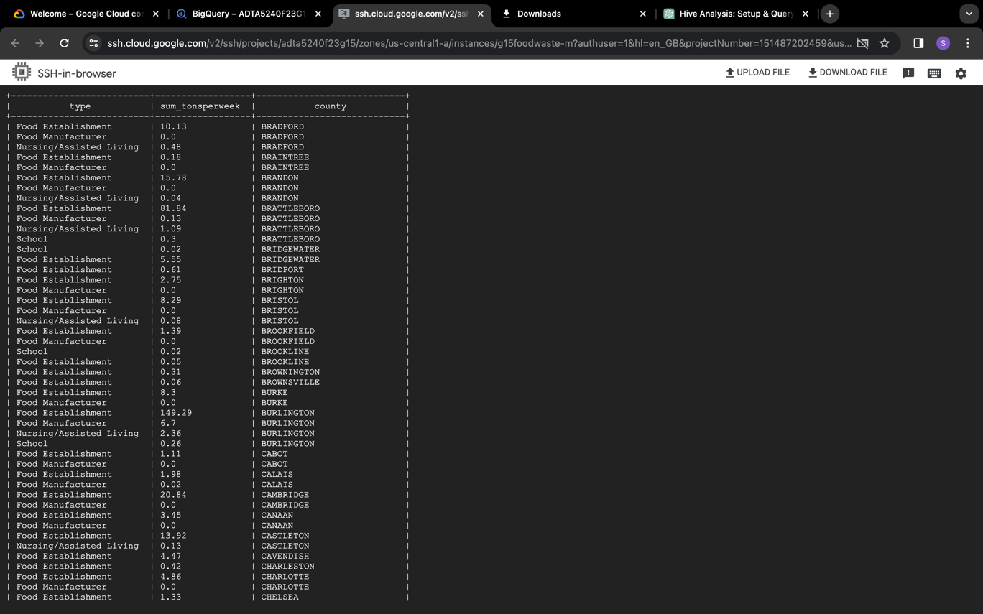

Query 2: SELECT round(sum(TonsPerWeek),2) as Sum_TonsPerWeek, county FROM foodwastestatic_1

Group by county;.

~~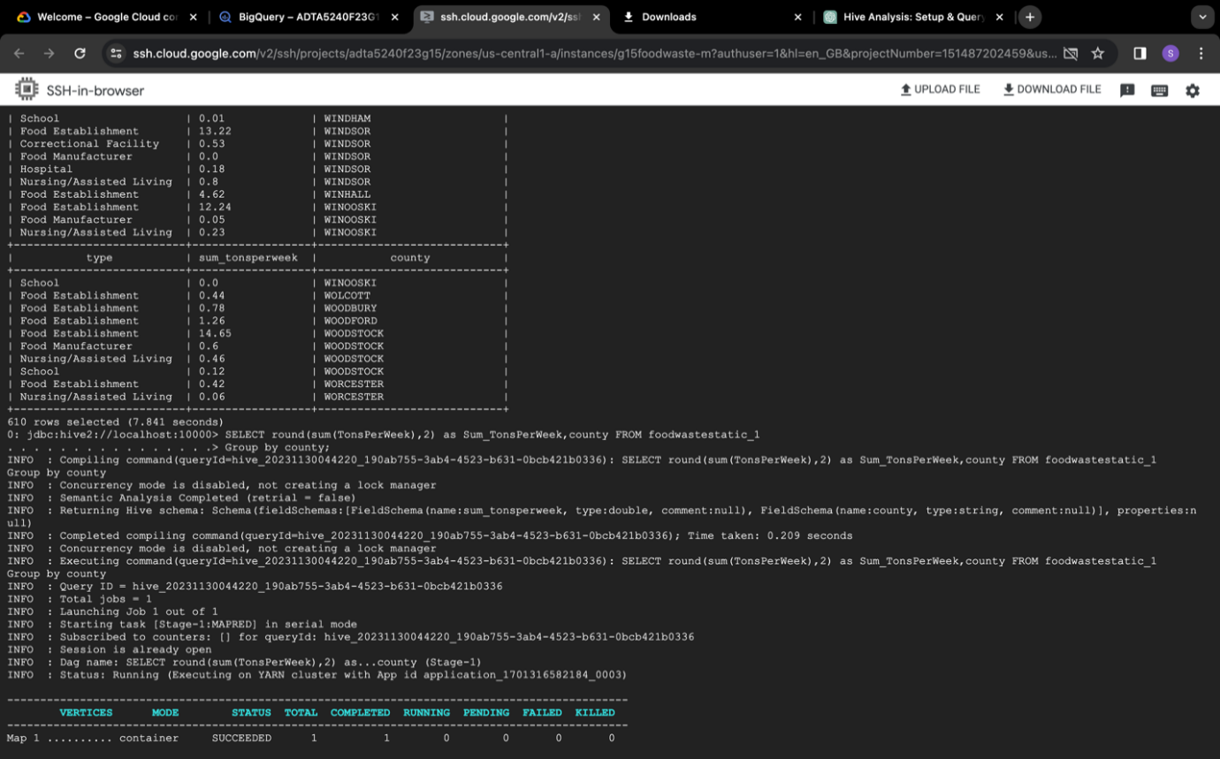~~

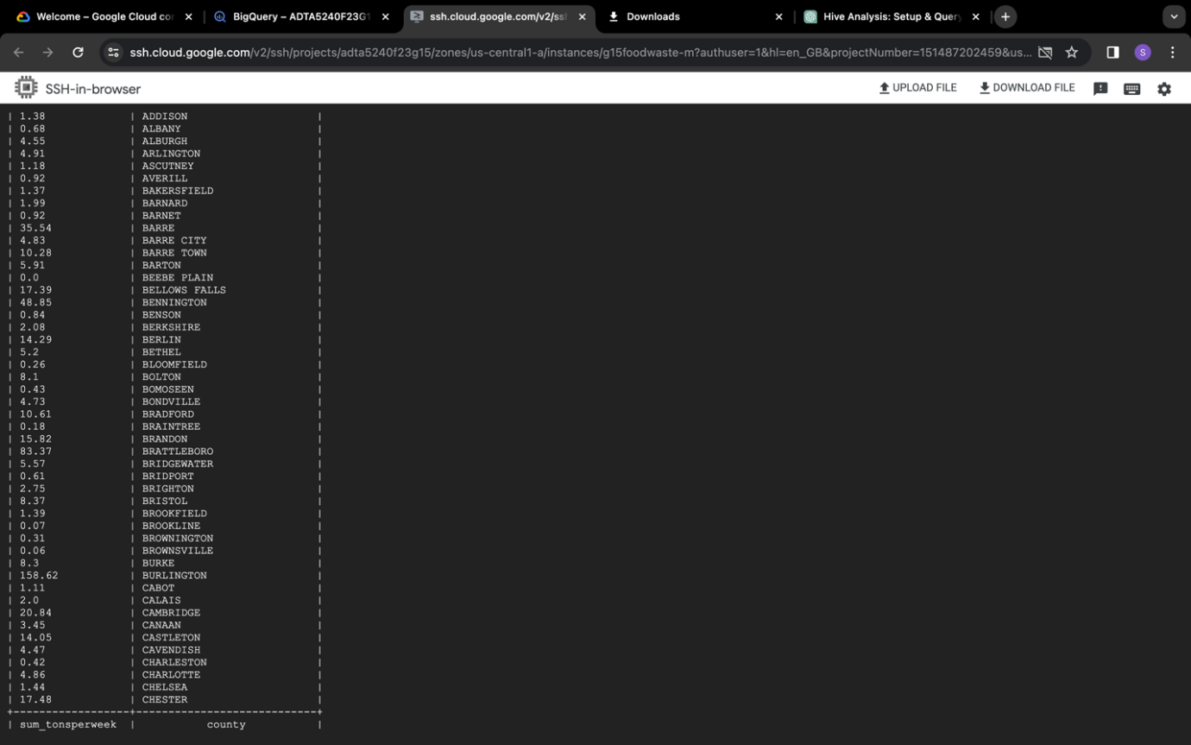

Query 3: SELECT * FROM foodwastestatic_1

WHERE type='Food Establishment' AND Sub_Type='Restaurant';.

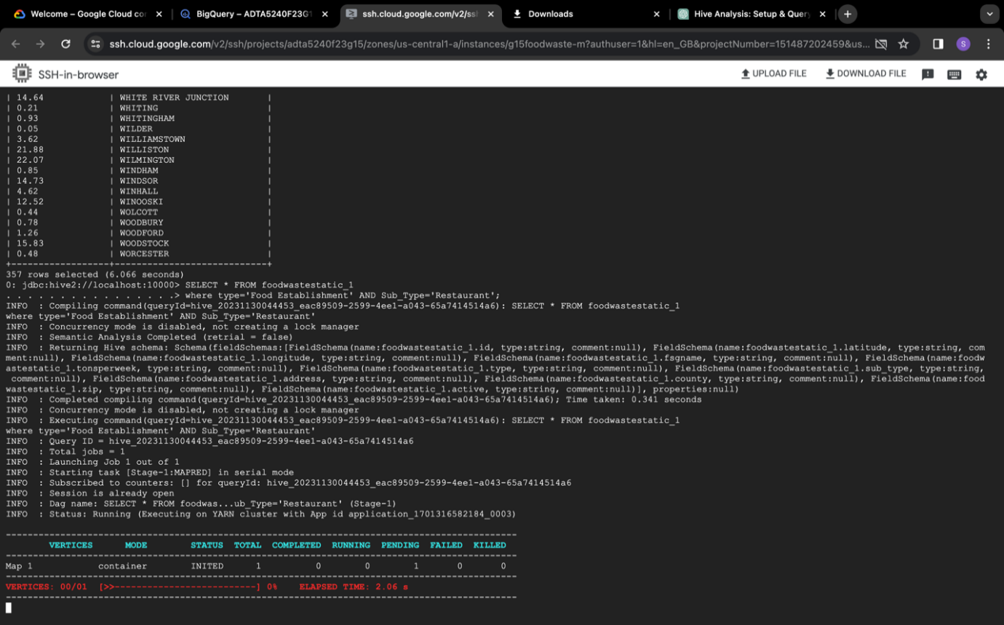

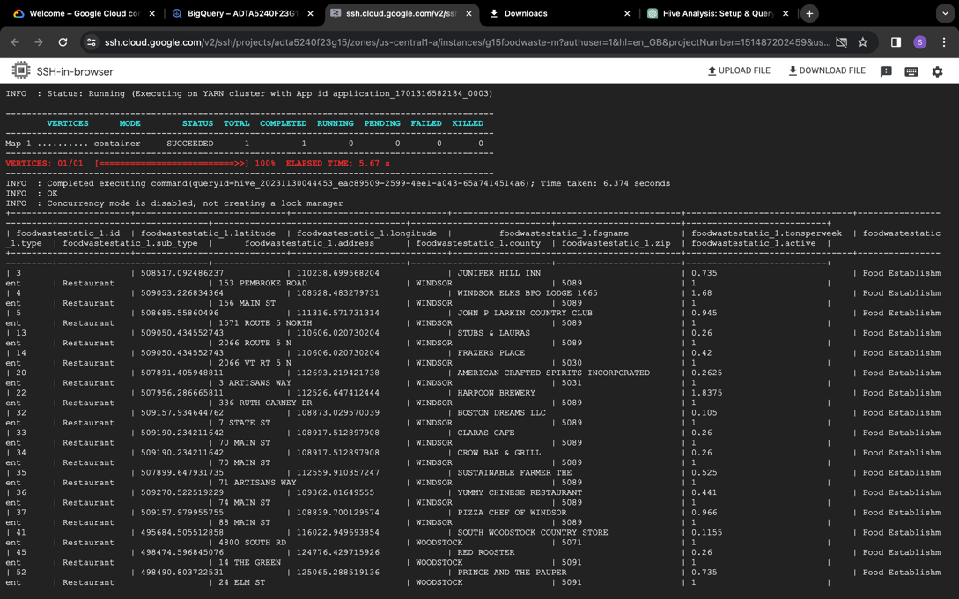

Query 4: select count(type) as Count_Type, zip, round(sum(TonsPerWeek),2) as Sum_TonsPerWeek from foodwastestatic_1

where type='Food Establishment'

group by zip;

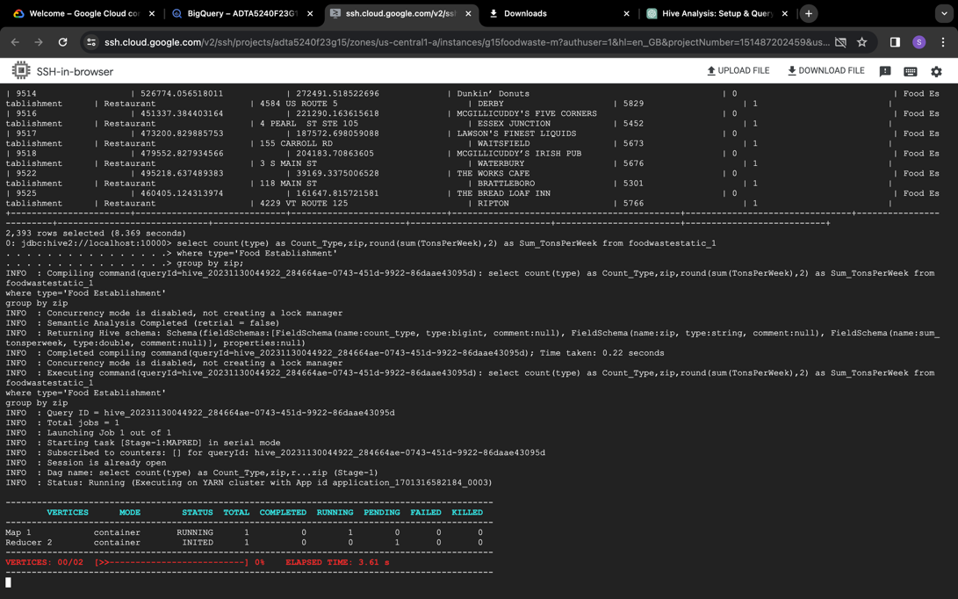

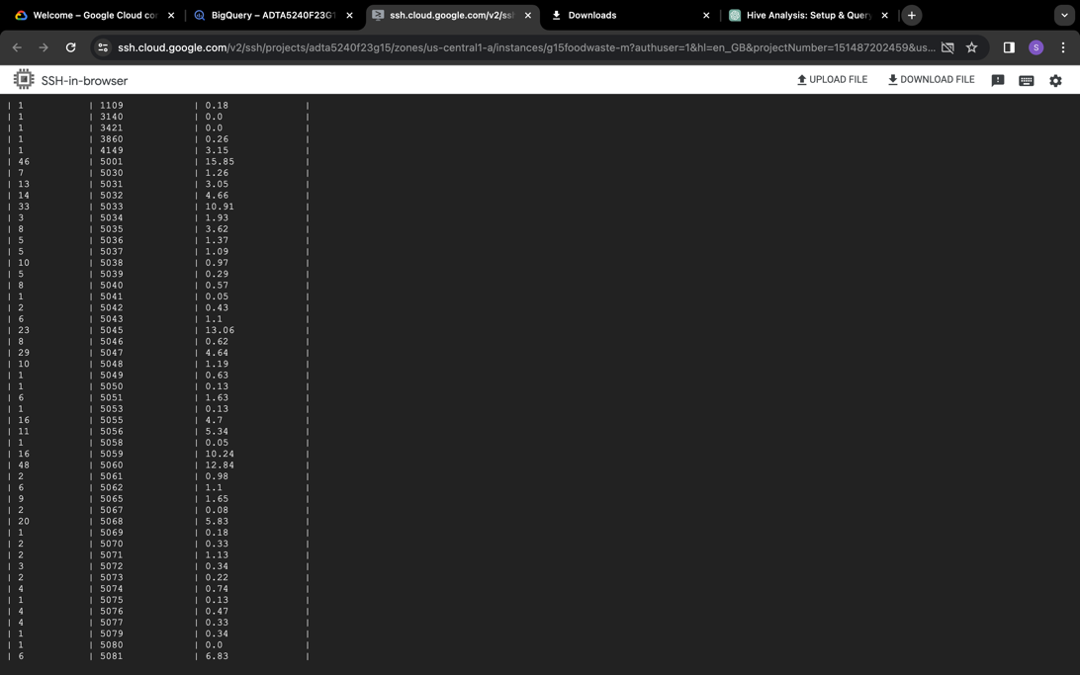

Query 5: select Sub_Type, round(sum(TonsPerWeek),2) as Sum_TonsPerWeek from foodwastestatic_1

group by Sub_Type;

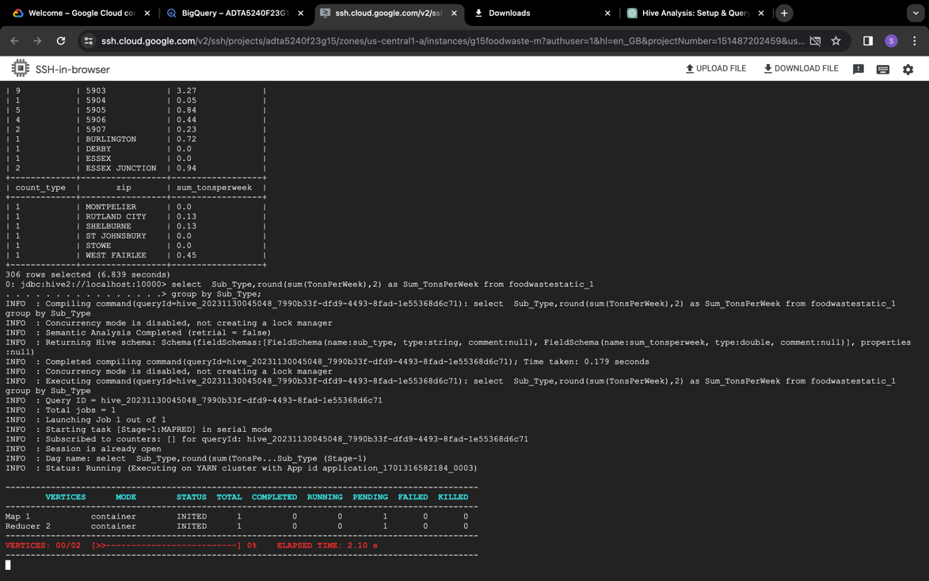

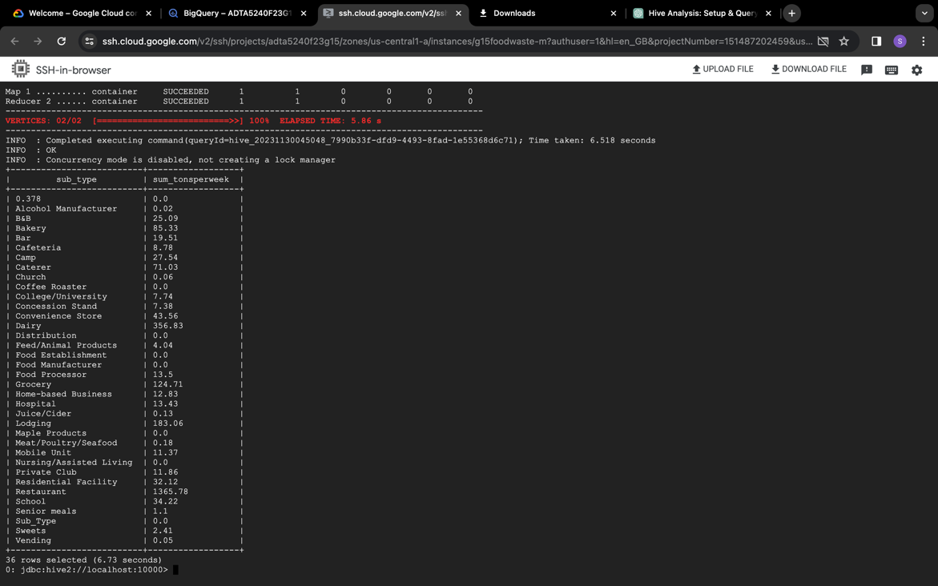

*Streaming Dataset 1:*

Query 1: SELECT cause_group, year, round (sum (tons_surplus_due_to_cause),2)as Sum_tons_Surplus FROM foodwaste_streaming_1

group by year, cause_group

order by year, Sum_tons_Surplus;

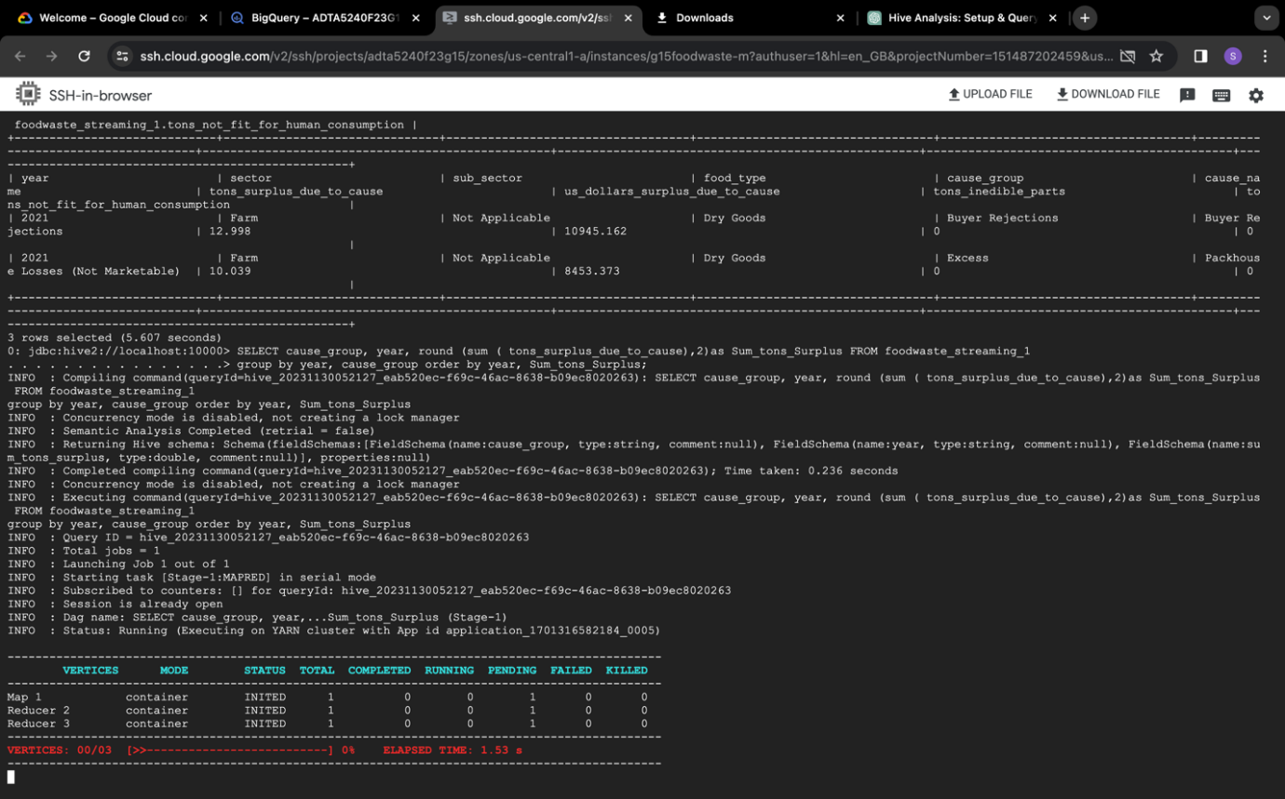

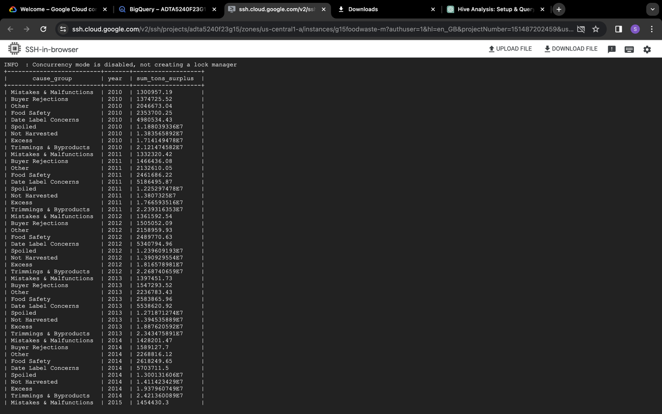 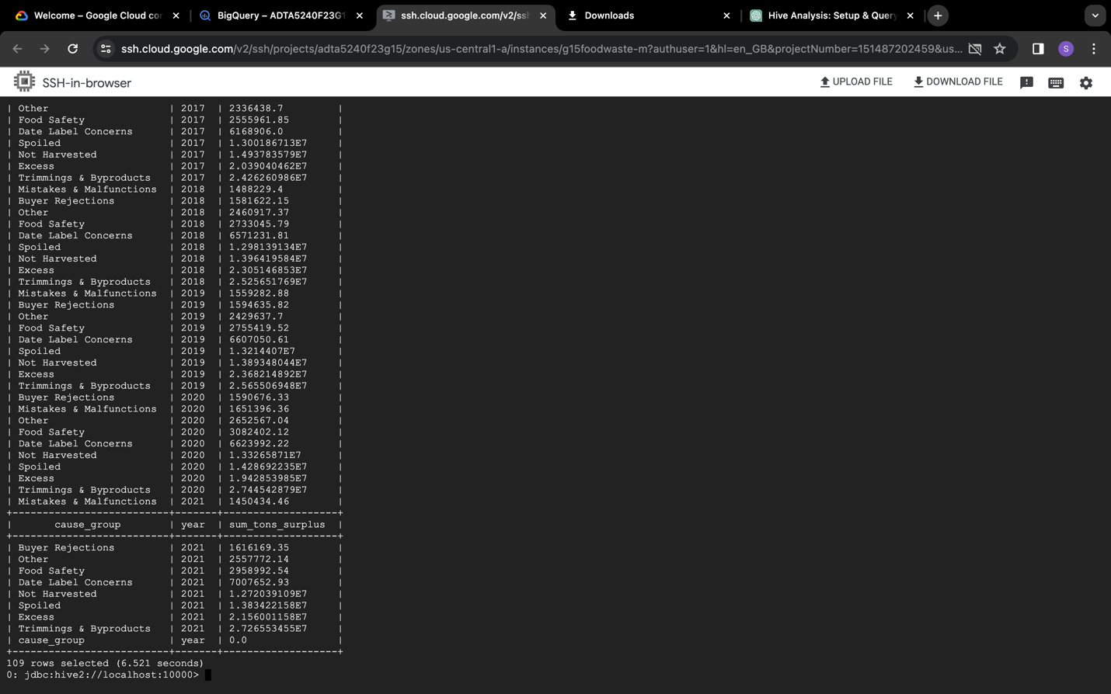

Query 2: SELECT sub_sector, round (sum(us_dollars_surplus_due_to_cause)) as

Sum_usdollars_Surplus, round(sum( tons_surplus_due_to_cause) ) as Sum_tons_Surplus

FROM foodwaste_streaming_1

group by sub_sector;

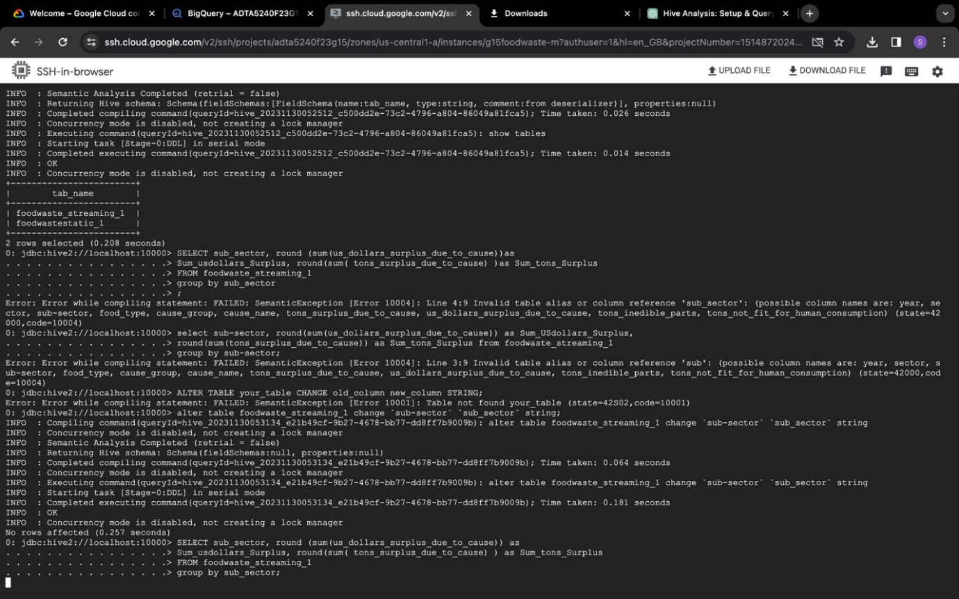

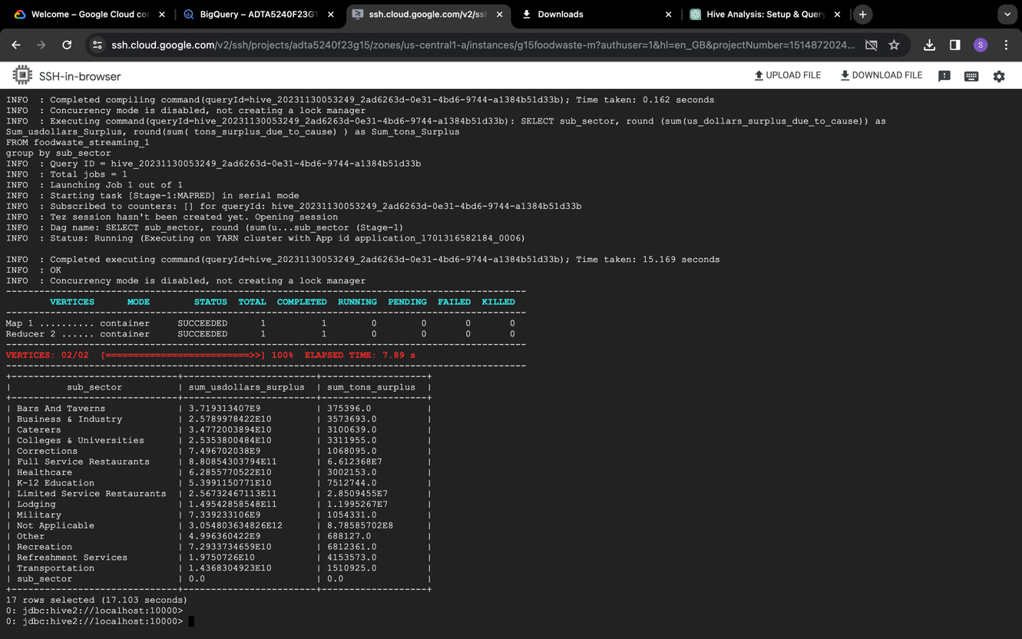

Query 3: SELECT sector, round (sum(us_dollars_surplus_due_to_cause)) as

Sum_usdollars_Surplus, round(sum(tons_surplus_due_to_cause) )as Sum_tons_Surplus

FROM foodwaste_streaming_1

group by sector;

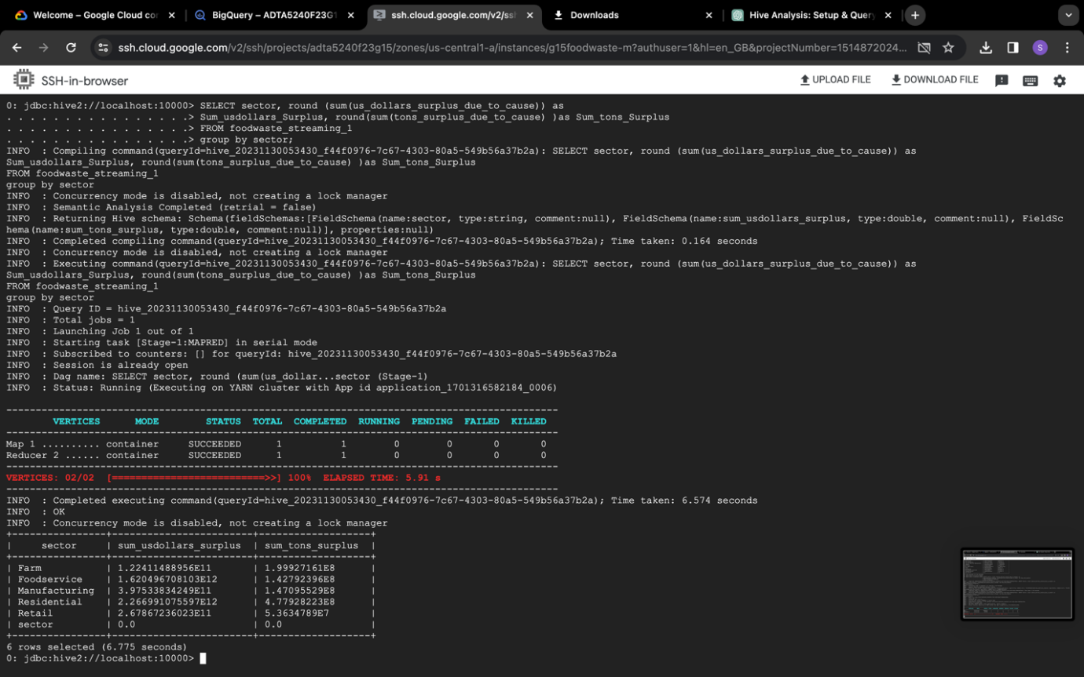

Query 4: SELECT sector, cause_group FROM foodwaste_streaming_1 group by sector, cause_group order by sector;

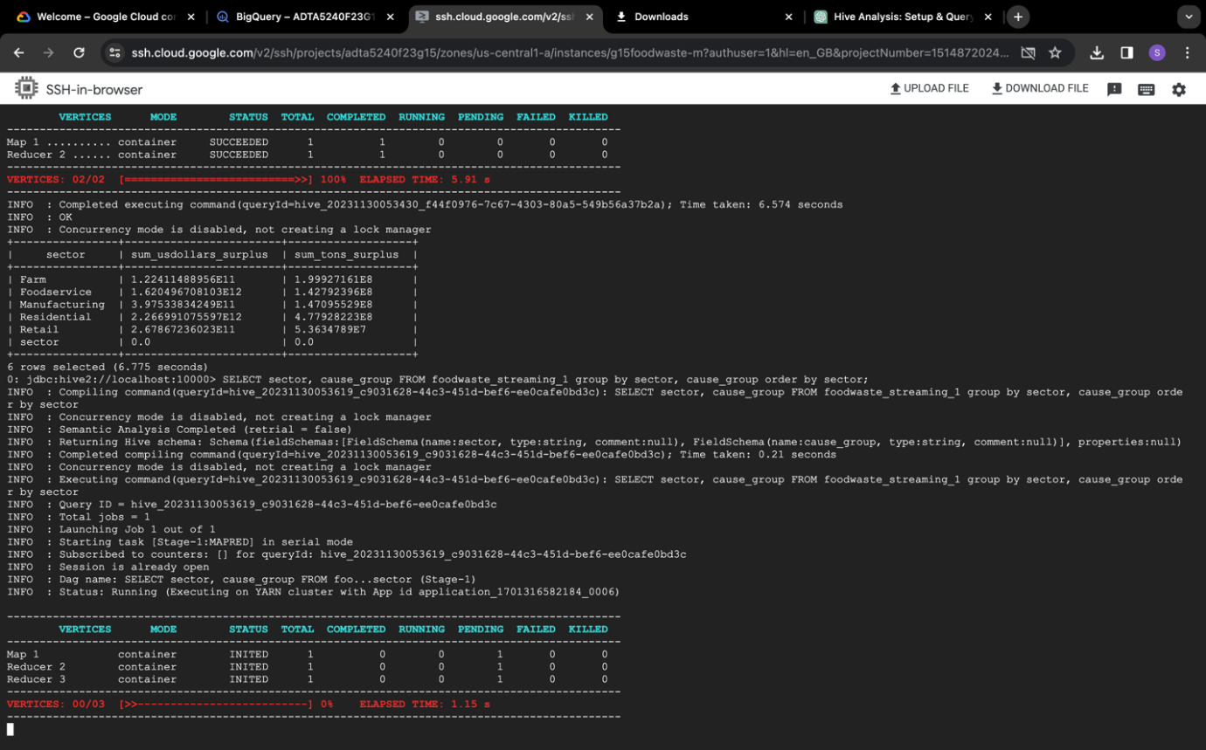

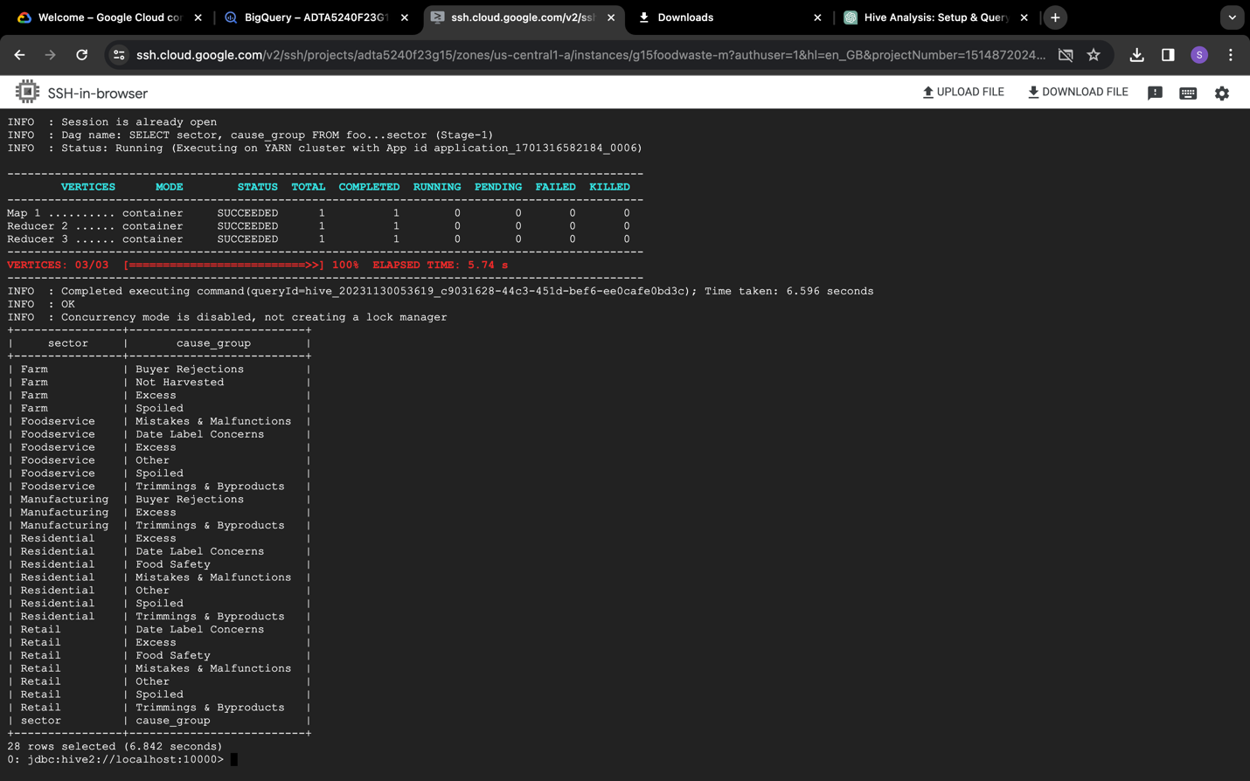

Query 5: SELECT food_type, round (sum (tons_surplus_due_to_cause), 2) as Sum_tons_Surplus FROM foodwaste_streaming_1

where year=2021

group by food_type

order by Sum_tons_Surplus limit 1;

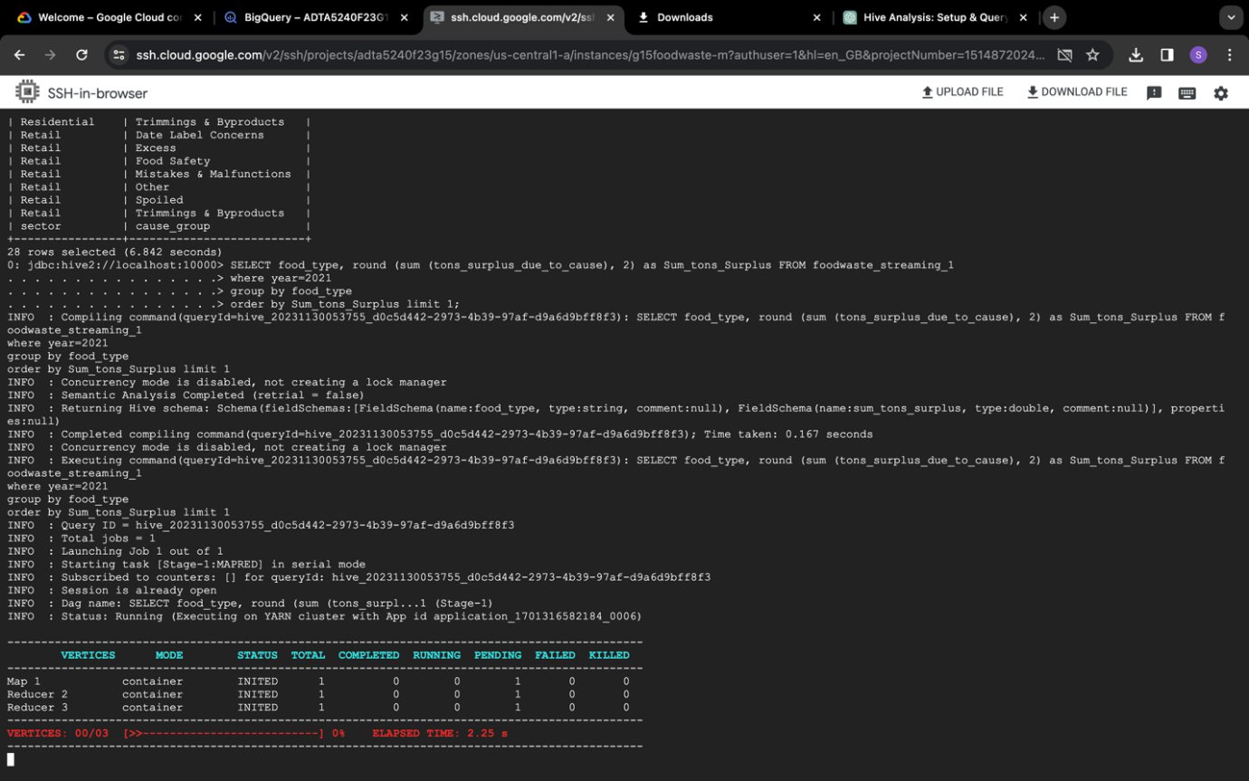

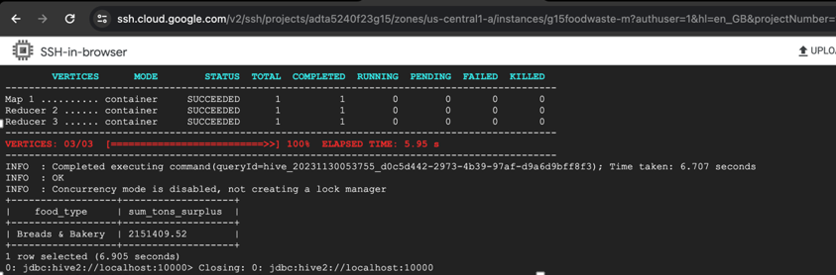

*Streaming Dataset 2:*

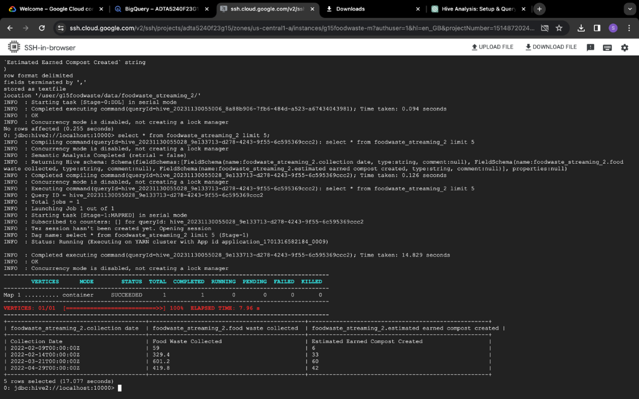

Query 1: SELECT * FROM foodwaste_streaming_2

order by Food_Waste_Collected desc

limit 10;

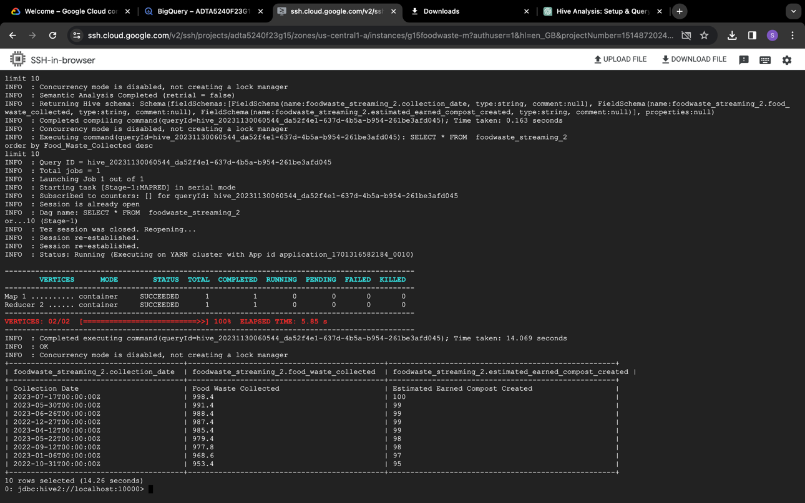

Query 2: SELECT * FROM foodwaste_streaming_2

where Collection_Date like ‘2023-06-19%’;

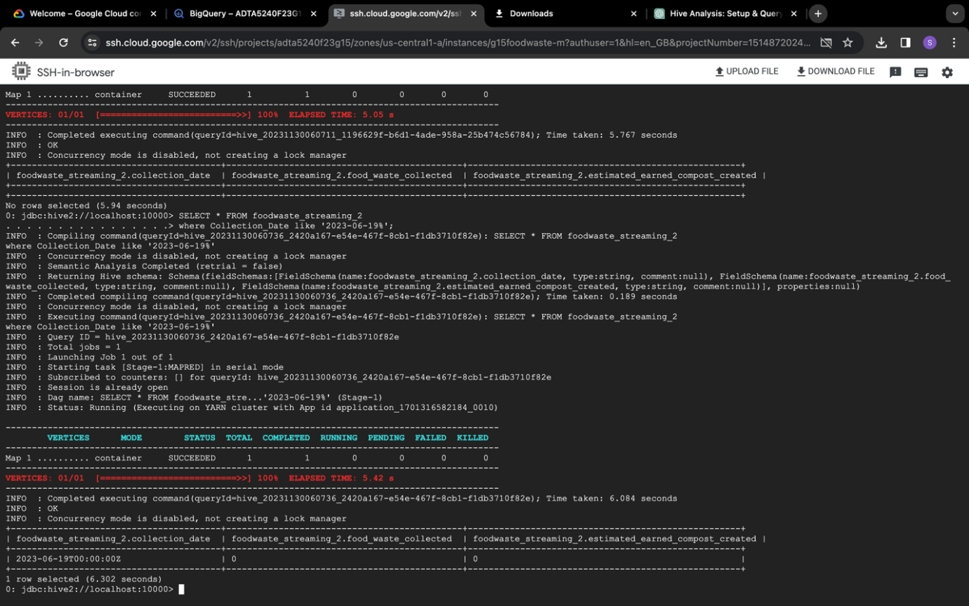

**Spark:**

*Static Dataset:*

Now, connecting to the **spark sql** and generated results for some queries.

Query 1: SELECT TYPE, round(sum(TonsPerWeek),2) as Sum_TonsPerWeek, County FROM foodwastestatic_1

Group by TYPE, County

Order by County;

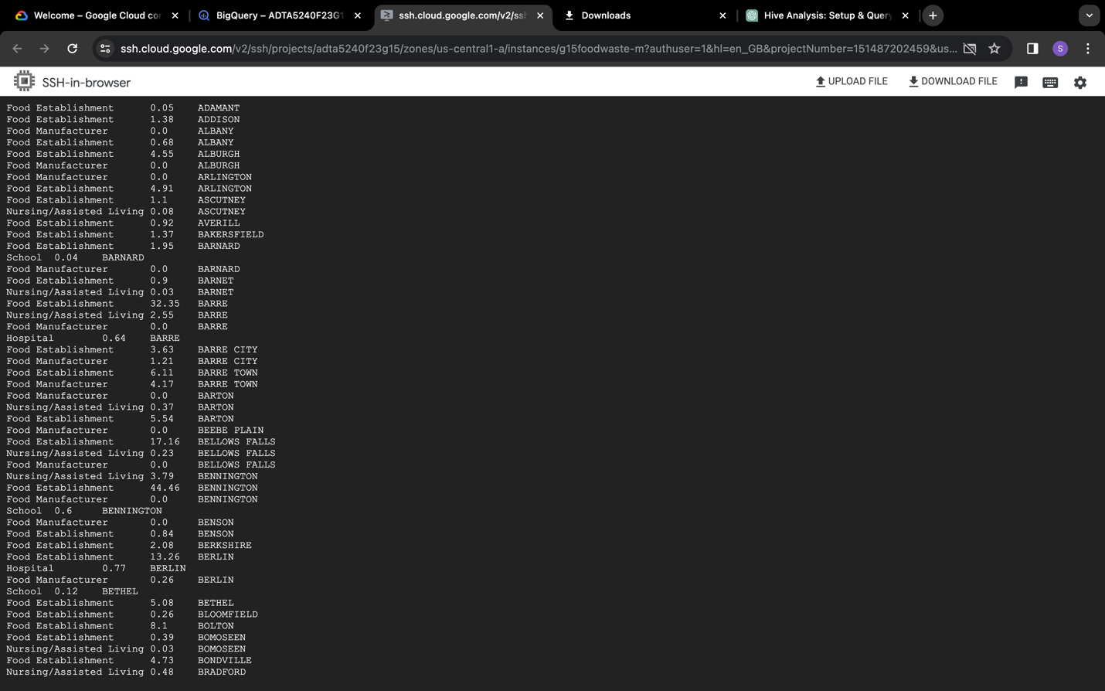 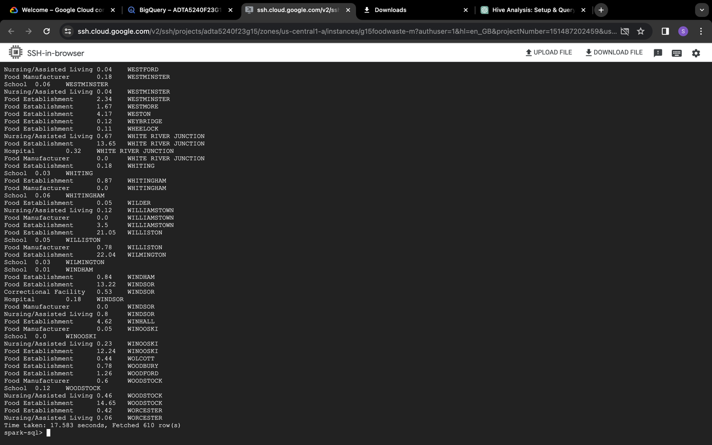

Query 2: SELECT round(sum(TonsPerWeek),2) as Sum_TonsPerWeek,county FROM foodwastestatic_1

Group by county;

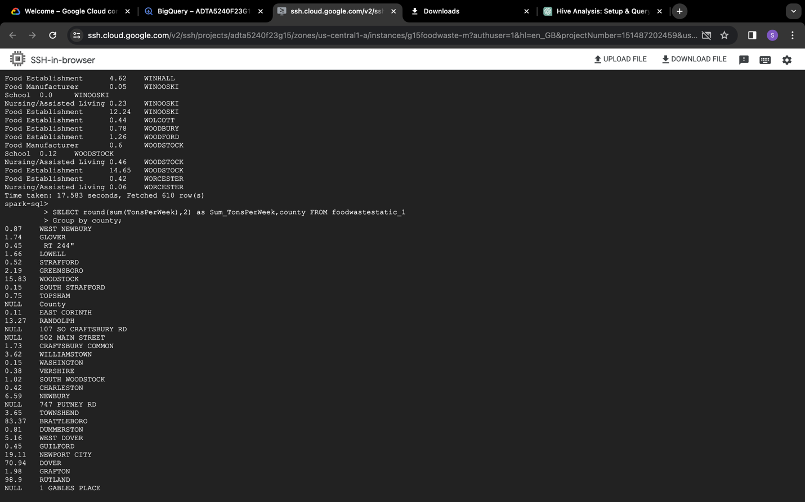 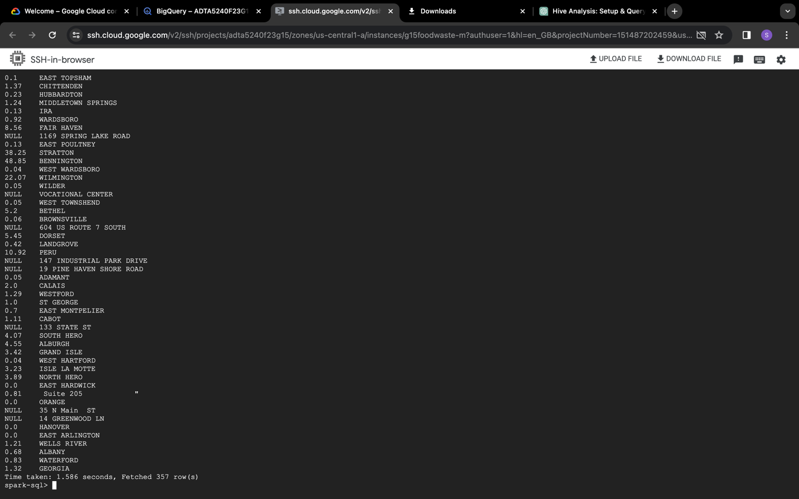

Query 3: SELECT * FROM foodwastestatic_1

where type='Food Establishment' AND Sub_Type='Restaurant';

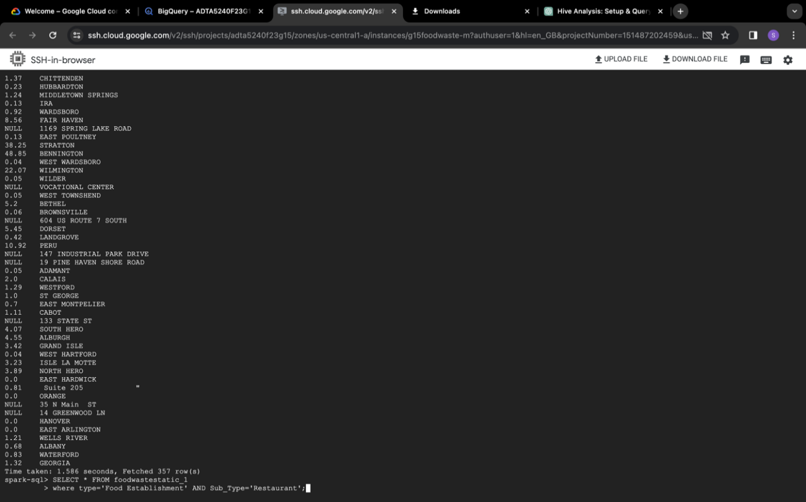

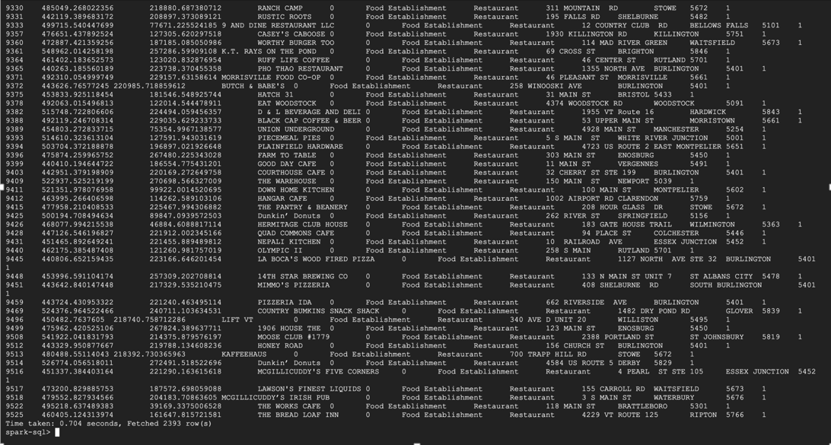

Query 4: select count(type) as Count_Type, zip, round(sum(TonsPerWeek),2) as Sum_TonsPerWeek from foodwastestatic_1

where type='Food Establishment'

group by zip;

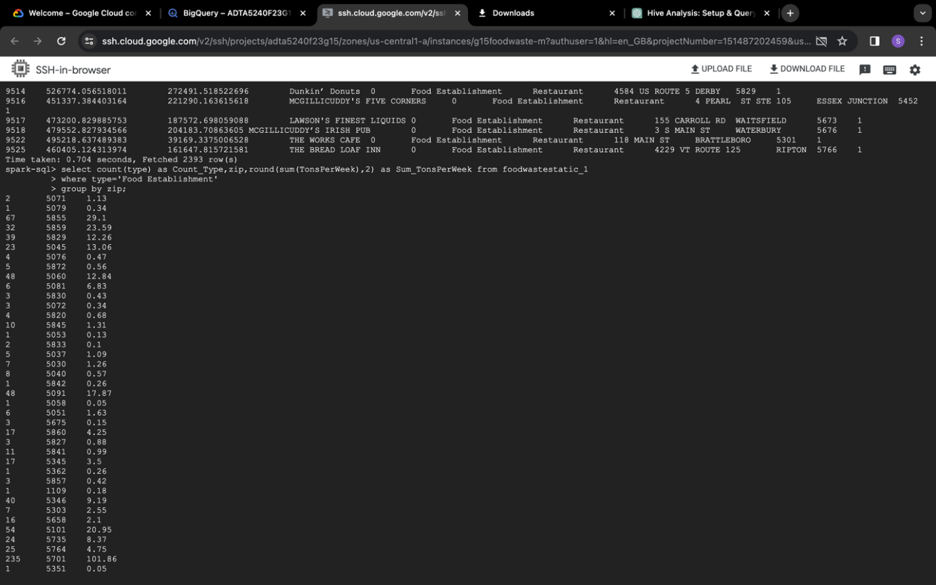

Query 5: select Sub_Type, round(sum(TonsPerWeek),2) as Sum_TonsPerWeek from foodwastestatic_1

group by Sub_Type;

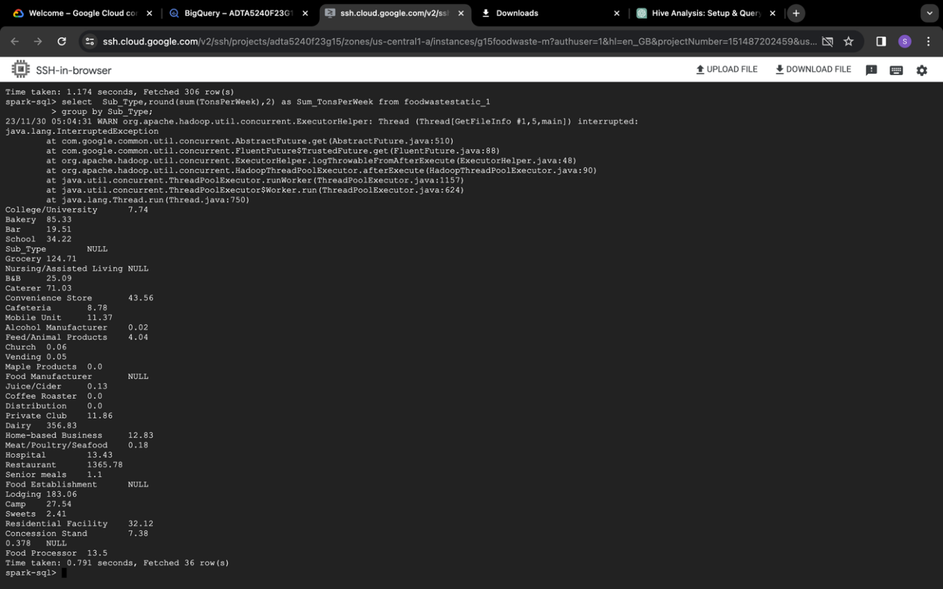

*Streaming Dataset 1:*

Query 1: SELECT food_type, round (sum (tons_surplus_due_to_cause), 2) as Sum_tons_Surplus FROM foodwaste_streaming_1

where year=2021

group by food_type

order by Sum_tons_Surplus limit 1;

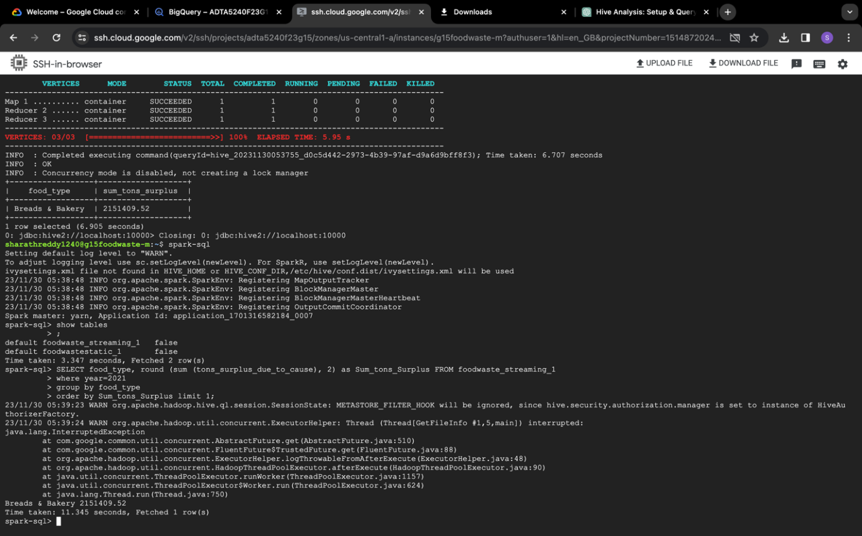

Query 2: SELECT sector, cause_group FROM foodwaste_streaming_1 group by sector, cause_group order by sector;

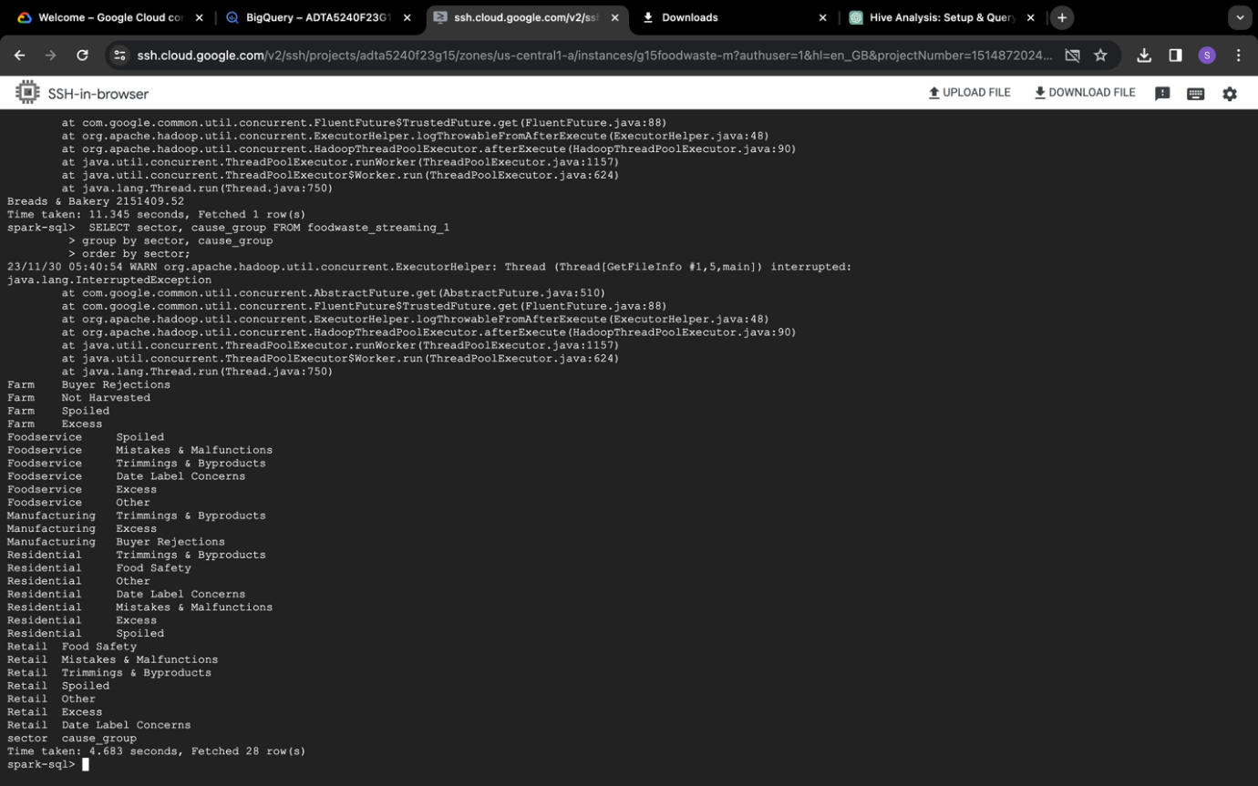

Query 3: SELECT sector, round (sum(us_dollars_surplus_due_to_cause)) as

Sum_usdollars_Surplus, round(sum(tons_surplus_due_to_cause) )as Sum_tons_Surplus

FROM foodwaste_streaming_1

group by sector;

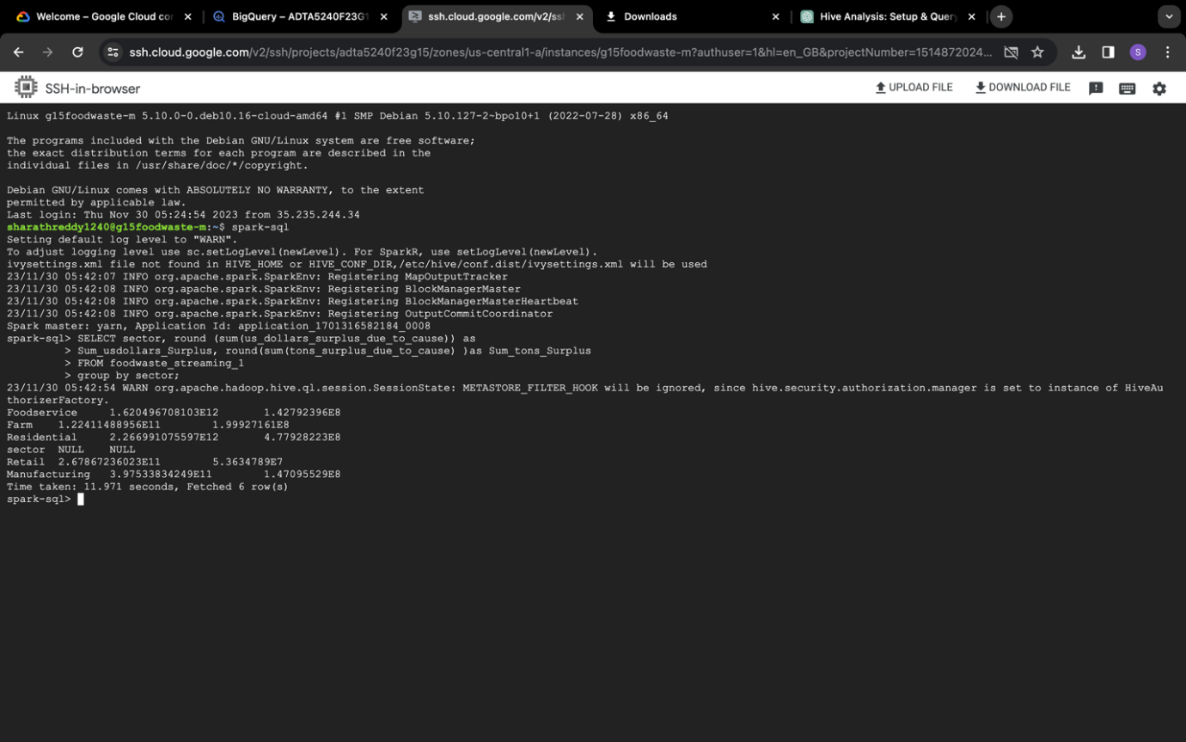

Query 4: SELECT sub_sector, round (sum(us_dollars_surplus_due_to_cause)) as

Sum_usdollars_Surplus, round(sum( tons_surplus_due_to_cause) ) as Sum_tons_Surplus

FROM foodwaste_streaming_1

group by sub_sector;

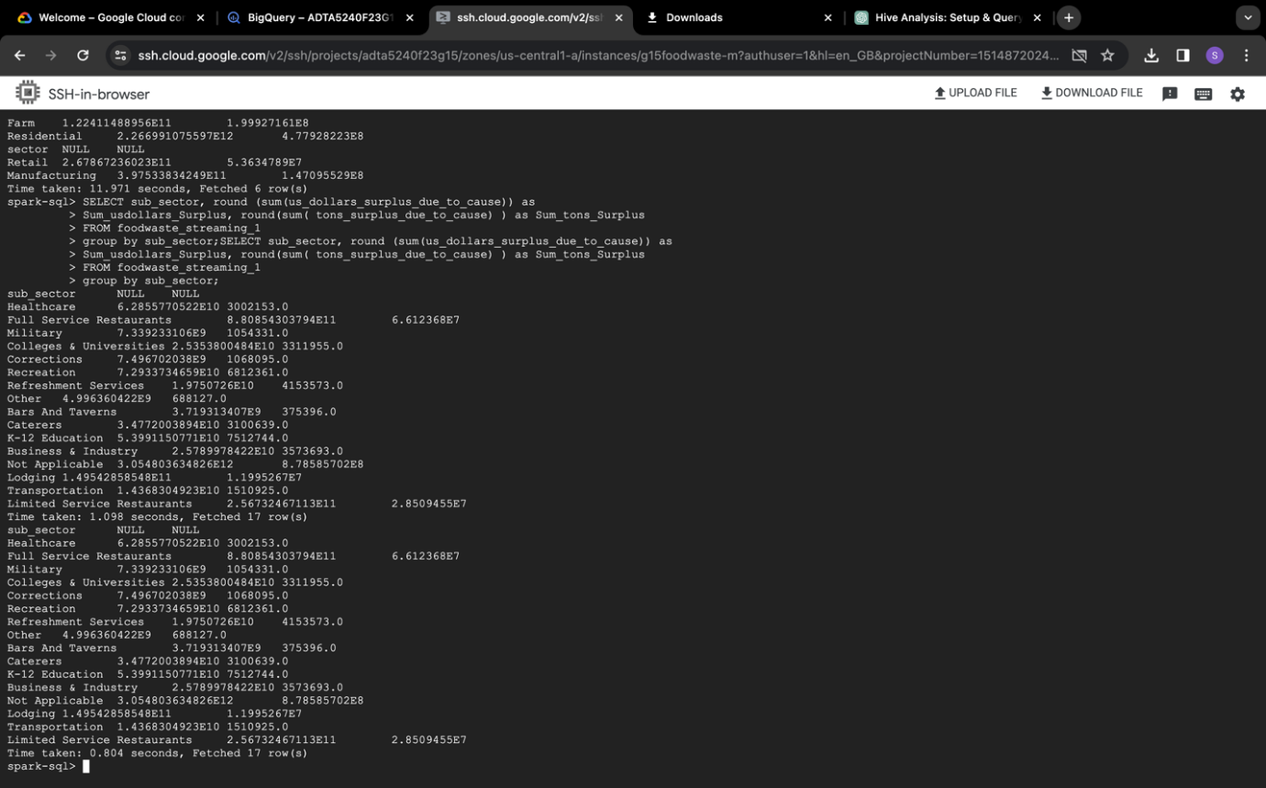

Query 5: SELECT cause_group, year, round (sum ( tons_surplus_due_to_cause),2)as Sum_tons_Surplus FROM foodwaste_streaming_1

group by year, cause_group order by year, Sum_tons_Surplus;

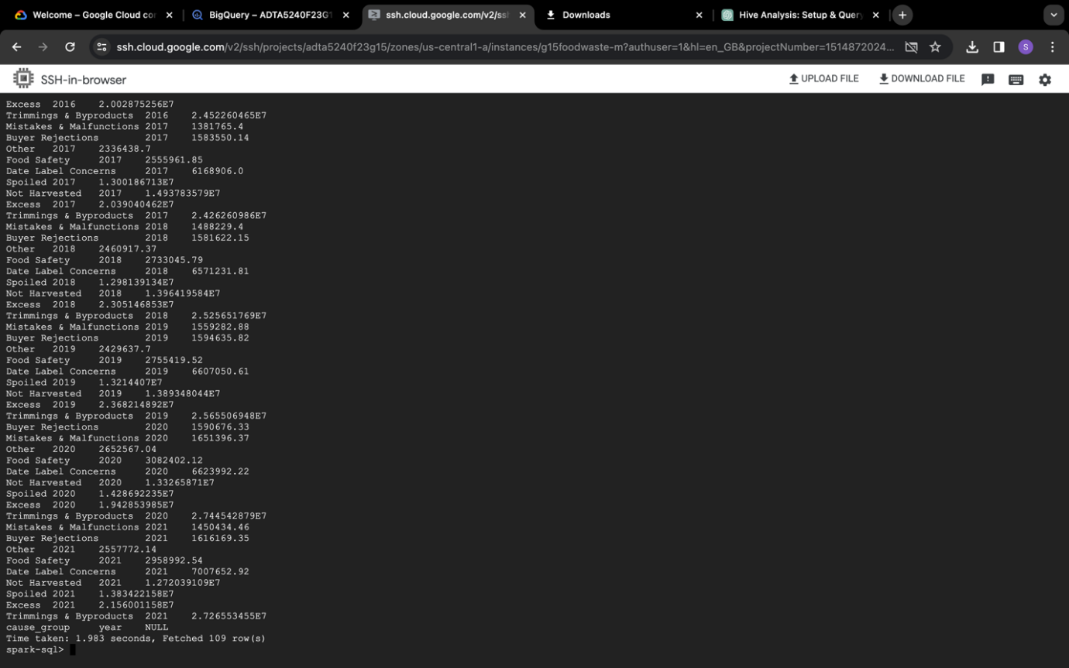

*Streaming Dataset 2:*

Query 1: SELECT * FROM foodwaste_streaming_2

order by Food_Waste_Collected desc

limit 10;

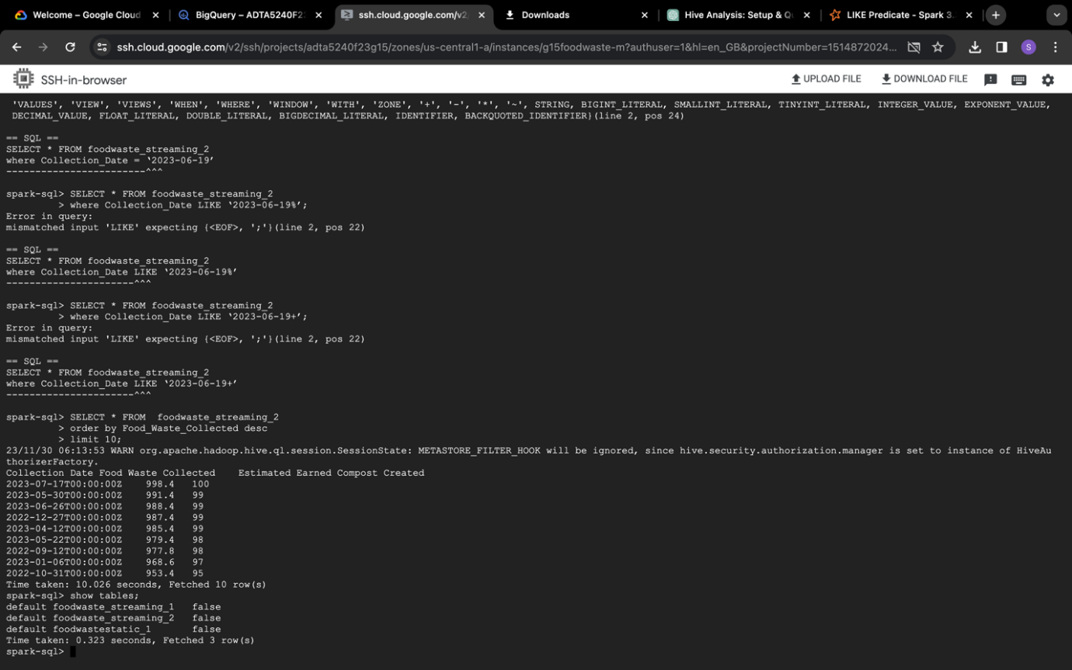

Query 2: SELECT * FROM foodwaste_streaming_2

where Collection_Date like ‘2023-06-19%’;

Here is the **time comparison chart** of Hive and Spark while running queries on both the platforms.

*Static Dataset:*

|  |  |  |
| --- | --- | --- |
| Query | Timetaken_Hive (in seconds) | Timetaken_Spark (in seconds) |
| 1 | 7.841 | 17.583 |
| 2 | 6.066 | 1.586 |
| 3 | 8.369 | 0.704 |
| 4 | 6.839 | 1.174 |
| 5 | 6.73 | 0.791 |

Streaming Dataset 1:

|  |  |  |
| --- | --- | --- |
| Query | Timetaken_Hive (in seconds) | Timetaken_Spark (in seconds) |
| 1 | 6.905 | 11.345 |
| 2 | 6.842 | 4.683 |
| 3 | 6.776 | 11.971 |
| 4 | 17.103 | 0.804 |
| 5 | 6.521 | 1.983 |

Streaming Dataset 2:

|  |  |  |
| --- | --- | --- |
| Query | Timetaken_Hive (in seconds) | Timetaken_Spark (in seconds) |
| 1 | 14.26 | 10.026 |
| 2 | 6.302 | - |

**References:**

Berman, D. (n.d.). Comparing Apache Hive vs. Spark. *logz.io*. <https://logz.io/blog/hive-vs-spark/>

Google Cloud. (n.d.). BigQuery overview. *BigQuery*. <https://cloud.google.com/bigquery/docs/introduction>

HBS Online. (2021, February 2). *8 Steps in the data life cycle*. <https://online.hbs.edu/blog/post/data-life-cycle>

Leal Filho, W., Ribeiro, P.C.C., Setti, A.F.F. et al. (2023, May 6). Toward food waste reduction at universities. *Environment, Development and Sustainability*. <https://doi.org/10.1007/s10668-023-03300-2>

Ramírez-Gallego, S., Krawczyk, B., García, S., Woźniak, M., & Herrera, F. (2017, May 24). A survey on data preprocessing for data stream mining: Current status and future directions. *Neurocomputing* (239). 29-57. <https://doi.org/10.1016/j.neucom.2017.01.078>